**Final Design Report**

Submitted to:

Brown Building

ATTN: Dr. Stebner (icw. Argonne Labs)

Submitted by:

**S15 - 06**

**Digital Image Calibration**

College of Engineering and Computational Sciences

Colorado School of Mines

Golden, Colorado 80401



CSM Capstone Design Program:

**Design Analysis and Verification Report/Final Design Report**

Team Members:

Karen Gilsdorf (kgilsdor@mymail.mines.edu), Dakota Hove (dhove@mymail.mines.edu),

Ann Miller (annmille@mymail.mines.edu), Joseph Schneider (josschne@mymail.mines.edu), Pouyan Sharifi (psharifi@mymail.mines.edu)

Team Leader: Ann Miller (annmille@mymail.mines.edu)

Faculty Adviser: Buddy Haun (bhaun@mines.edu)

Technical Consultant: Dr.Jason Porter (jporter@mines.edu)

October 22, 2015

**Acknowledgments**

The Finesse Digital Image Correlation Team would like to acknowledge Buddy Haun, Garrison Hommer, Jun-Sang Park, Andy Peterson, Jason Porter, and Aaron Stebner for their help and support throughout this project.

**Table of Contents**

List of Figures 5

List of Tables 6

Executive Summary 7

1. Introduction: Project Review 8

2. Application of Design Methodology 8

3. Engineering Analysis 16

3.1 Project Constraints 16

3.2 Load Frame Interface Requirements 18

3.3 Machined/Off-the-Shelf Tolerance Analysis 20

3.4 Deflection Analysis 21

3.5 Repeatability Analysis 21

3.6 Force and Torque Analysis 22

3.7 Moment Analysis 22

3.8 Analysis Results 22

3.9 Risk Mitigation 22

4. Final Deliverables 23

4.1 Camera Mounting Systems 23

4.1.1 Camera Mounting System for CSM Uniaxial Load Frame 23

4.1.2 Camera Mounting System for CSM Biaxial Load Frame 24

4.1.2 Camera Mounting System for Argonne Labs Biaxial Load Frame 24

4.2 Calibration Target 26

4.3 Bill of Materials/ Engineering Drawings 26

4.4 Operator's Manual 26

4.5 Project Validation 26

5. Project Management 26

5.1 Work Breakdown Schedule 26

5.2 Schedule 27

5.3 Budget 27

5.4 Outstanding Work. 27

6. Lessons Learned 28

Appendix A: Schedule 30

Appendix B: Preliminary & Final Budget 32

Appendix C: Deflection Analysis 34

Appendix D: Force & Torque Analysis 37

Appendix E: Moment Analysis 38

Appendix F: Angled Base Plate Calculations 40

Appendix G: Final Parts List 42

Appendix H: Bill of Materials 43

Appendix I: Operators Manual 50

# List of Figures

Figure 1 - Engineering Design Process 9

Figure 2 - Blackbox Calibration Process 9

Figure 3 - Working Envelope 10

Figure 4 - Conceptual Automated Design 11

Figure 5 - Conceptual Semi-automated Design 12

Figure 6 - Conceptual Manual Design 13

Figure 7 - Intermediate Design for Next Steps Letter 14

Figure 8 - Final Calibration Target Design 15

Figure 9 - Mounting System Component Labels 17

Figure 10 - Final Calibration Target Design with Labels 17

Figure 11 - Uni-axis Load Frame 19

Figure 12 - CSM Dual Axis Load Frame 19

Figure 13 - Argonne Labs Dual Axis Load Frame 19

Figure 14 - Swept Circle of Dual Axis Load Frame Motion 20

Figure 15 - Uniaxial Load Frame Final Design 24

Figure 16 - CSM Dual Axis Load Frame Final Design 24

Figure 17 - Argonne Labs Load Frame Final Design 25

Figure 18 - Actuator Movement Capabilities 25

Figure 19 - Work Breakdown Schedule 27

Figure 20 - Camera Plate von Mises Stress Analysis 34

Figure 21 - Camera Plate Deflection (Y) Analysis 34

Figure 22 - C-Channel Deflection Analysis 35

Figure 23 - C-Channel Von Mises Analysis 35

Figure 24 - Column Analysis Von Mises Stress Analysis 36

Figure 25 - Column Deflection Analysis 36

Figure 26 - Column Deflection Analysis 37

Figure 27 - Torque Calculations 38

Figure 28 - Resulting Moment on C-Channel Analysis 39

Figure 29 - Angled Base Plate Placement Analysis 40

Figure 30 - Angled Base Plate Placement Analysis Cont. 41

Figure 31 - Angled Base Plate Hole/Angle Options 42

Figure 32 - Camera Bracket 43

Figure 33 - Laser Mount 44

Figure 34 - Cantilever Bar (C-Channel) 44

Figure 35 - Angled Base Plate 45

Figure 36 - Calibration Target L-Bracket 45

Figure 37 - Uniaxial Load Frame Configuration 50

Figure 38 - Dual-Axis (CSM) Load Frame Configuration 50

Figure 39 - Dual-Axis (Argonne Labs) Load Frame Configuration 50

Figure 40 - Calibration target Assembly 51

Figure 41 - Assembled Calibration Target 51

# ****List of Tables****

Table 1 – Movement Requirements 18

Table 2 - Tolerance Requirements 18

Table 3 - Maximum Deflections 21

Table 4 - Worst Case Scenarios for Final Design (Tolerance Stack) 22

Table 5 - Risk Mitigation 23

Table 6 – Preliminary Budget 32

Table 7 - Final Budget 33

Table 8 - Load Capacity Analysis 37

Table 9 - Total Weight Summation Applied to Actuator 38

Table 10 – Final Parts List 42

**Final Design Report**

Prepared by Ann Miller, Dakota Hove, Joseph Schneider, Karen Gilsdorf, Pouyan Sharifi

Team # 15-06

Finesse Digital Image Correlation

College of Engineering and Computational Sciences

Colorado School of Mines

# Executive Summary

The mechanical department at Colorado School of Mines is on the front lines of promoting growth and progress in a multitude of engineering areas, including Mechanics of Materials. The Beam Team, collaboration between the CSM Solid Mechanics Lab and Argonne National Laboratory in Illinois, founded by Dr. Aaron Stebner, is a research group that focuses on deformation modes in materials “using novel characterization and modeling techniques.” In order to study these modes appropriately, the team utilizes a variety of different measurement devices, including strain measurement cameras. The data gathered by these cameras is utilized to propagate further research, and has applications in areas such as aerospace engineering and design. In order to gather accurate data, two cameras are mounted at an angle from the load frame currently in use. Currently, the Beam Team has a rudimentary camera mounting system, which results in the calibration of these cameras taking up to a day, and therefore restricting the lab’s ability to use the cameras to their full potential. Additionally, the lab has recently acquired a bi-axial tension load frame that requires a more robust camera mount, and has purchased time to use the Argonne Labs biaxial tension load frame. In order to create a camera mounting system that fully meets all of these requirements, and allows for a fast and accurate calibration, the Beam Team has contacted Finesse Digital Image Correlation (DIC) to design, analyze, and build a new system.

In this final design report, Finesse DIC will fully specify the digital image calibration and mounting system that has been designed for the Colorado School of Mines Solid Mechanics Laboratory. Through a project iteration process and extensive engineering analysis, this design has been deemed the most technically and financially feasible option for the client; Dr. Aaron Stebner. The overall design includes two camera mounting systems that pertain respectively to each load frame being used by the department; the CSM uniaxial load frame, CSM biaxial load frame, and the Argonne Labs biaxial load frame. This mounting system is also adaptable for two sets of cameras; Baumer and Basler. In addition to the camera mounting apparatuses, a modified calibration target requested by the client was included in our design package. Within this report will be a full breakdown of the design process. This will include component decision processes for each individual part of the design, as well as detailed insight into the design methodology of the team, engineering analysis, the broader impacts of the design, and finally lessons learned from this year long project.

**Final Design Report**

Prepared by Ann Miller, Dakota Hove, Joseph Schneider, Karen Gilsdorf, Pouyan Sharifi

Team # 15-06

Finesse Digital Image Correlation

College of Engineering and Computational Sciences

Colorado School of Mines

# 1. Introduction: Project Review

The Beam Team, a research group that works in conjunction with the Mechanics of Materials Lab at Colorado School of Mines and Argonne Labs, has tasked the Finesse Digital Image Correlation team with designing and building a new mechanism to calibrate two sets of strain cameras. The mechanism required for this calibration includes a camera mounting system for two cameras, each placed at an angle from the sample, as well as a calibration target. The cameras are used to measure strain in a sample held by three separate load frame configurations. These three separate configurations correspond to the Colorado School of Mines owned uniaxial load frame and biaxial load frame, as well as the Argonne Labs owned biaxial load frame. Each separate load frame requires different calibration capabilities, and therefore a different mounting system. Finesse DIC team has designed and built a camera mounting system that can be configured in three separate manners to interface appropriately with each load frame. The specific motion capabilities of each system vary slightly, and are outlined in Section 4. However, the basic outline of the movement capabilities required by the client can be seen in Figure 37 - Uniaxial Load Frame Configuration. In addition to a camera mounting system, Finesse DIC has created a calibration target for the strain measurement cameras to utilize during the calibration process, ensuring the appropriate focal point has been reached. The calibration target interfaces directly with the CSM owned uniaxial load frame. The specific movement capabilities of this are outlined in Table 1 – Movement Requirements.

Through careful design and analysis, in conjunction with direct communication between the team, client, and consultant, Finesse DIC has created the camera mounting systems and calibration target that meets all needs of the project.

# 2. Application of Design Methodology

The first step to understanding the project was to understand the current state of the problem. Finesse DIC executed a mock calibration with the original system to create a firsthand understanding of what capabilities the system must have in order to complete a successful calibration and experiment. Based on the mock calibration, the team identified the requirements to calibrate the cameras for each separate load frame, and verified these motion capability requirements with client. The team also compiled appropriate tolerance requirements for each component, and verified these with the client. The camera mounting system requires specific movement capabilities that are precise and repeatable, within optical tolerances, and allows the calibration to be completed in a short amount of time. These specifications have been outlined to their full extent in Table 1 – Movement Requirements and Table 2 - Tolerance Requirements.

This project was an iterative process as the understanding and priorities of the project became clear. The following diagram illustrates how the team iterated the design with continual brainstorming and analysis to create the design that best met the client’s needs.

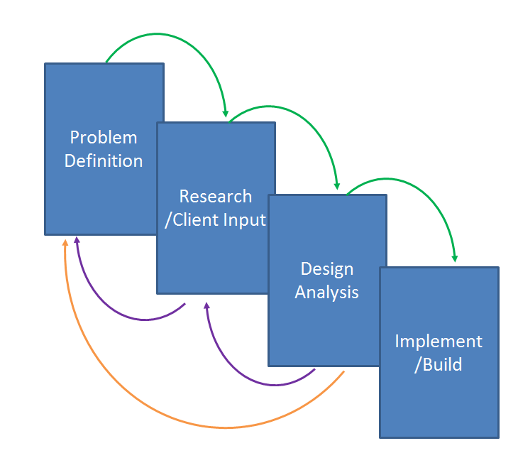

Figure 1 - Engineering Design Process

Using this design methodology, Finesse DIC compiled all required components into a black box framework. This allowed the team to combine all required aspects of a successful calibration, and separate them adequately into a Work Breakdown Schedule, as seen in Figure 19 - Work Breakdown Schedule.

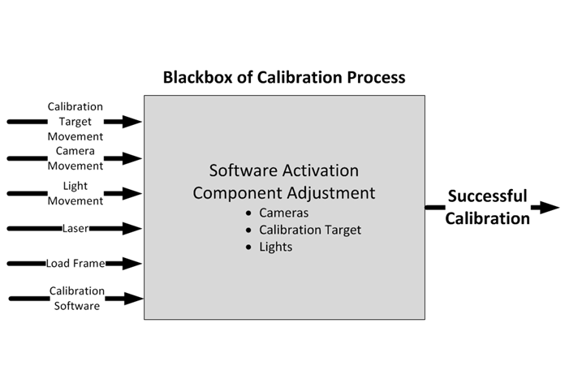

Figure 2 - Blackbox Calibration Process

The first significant milestone of the design process was drafting the team’s understanding of the project clearly in the letter of intent. This letter clearly outlined the team’s understanding of the project deliverables, schedule, budget, and scope of the project. The schedule and final cost of the project are included in Appendix A and B respectively. This letter was then given to the client in a meeting, where the scope of the project was finalized.

With constructive feedback and clarifications from the client meeting and letter of intent, the team next prioritized the needs of the client and began brainstorming solutions to solve the problem and execute a successful design. Finesse DIC came up with a rough estimate for the new camera mounting system placement, as it is aligned with the uniaxial load frame, as a main framework from which to build ideas.

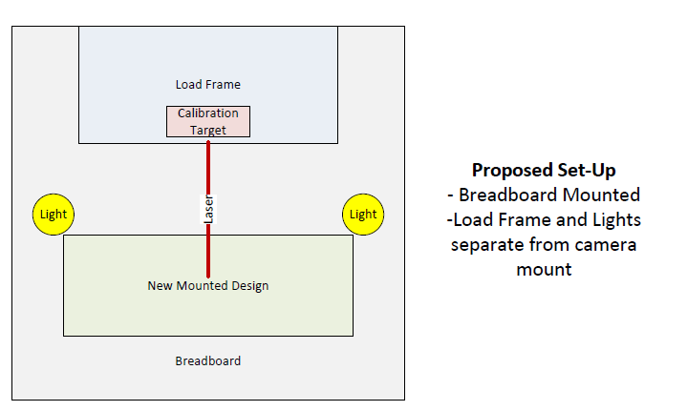

Figure 3 - Working Envelope

Two brainstorming sessions were conducted by the team: first, the team subdivided into groups of two to have brainstorming sessions, second the team reconvened to share ideas and expand on the ideas of the subgroups. The ideas from the brainstorming sessions were condensed into three conceptual designs: the automated, semi-automated, and manual design. The three conceptual designs are pictured in the following three figures: Figure 4 - Conceptual Automated Design, Figure 5 - Conceptual Semi-automated Design, and Figure 6 - Conceptual Manual Design.

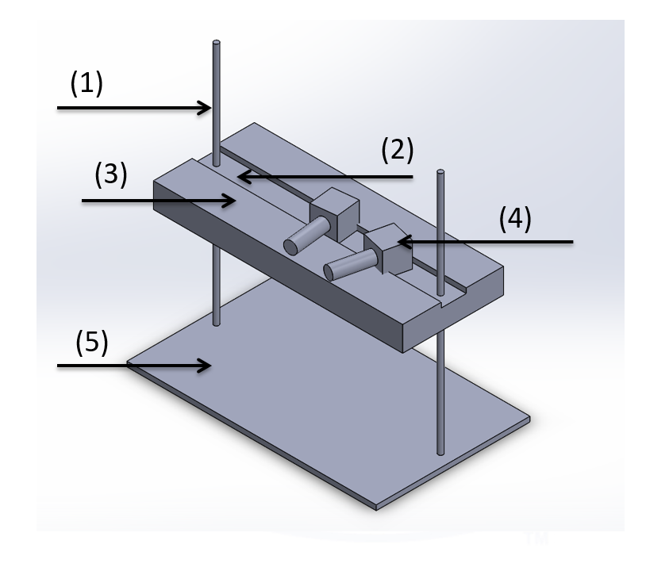

Figure 4 - Conceptual Automated Design

1) Ball Screw

2) Linear Camera Positioning actuators

3) Z-stage positioning block

4) Camera

5) Table Mounting board

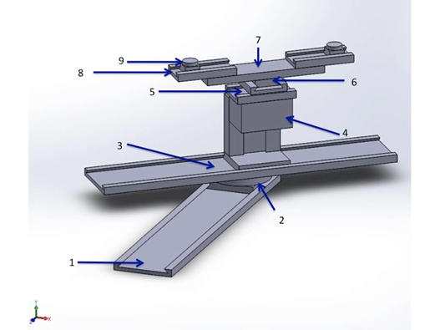

Figure 5 - Conceptual Semi-automated Design

Labeled Components:

1) Z-direction lateral motion component. This will be mounted to the breadboard

2) Course rotational component

3) Lateral motion component: similar to (1), but subject to direction change due to (2).

4) Existing Y-Stage (scissor lift)

5) Existing fine adjustment lateral motion components (with replaced screws)

6) Extension bar for component (7).

7) Very fine lateral motion components (x2 – one for each camera)

8) Very fine rotational component (x2 – one for each camera). Cameras are mounted directly to the top of this rotational component.

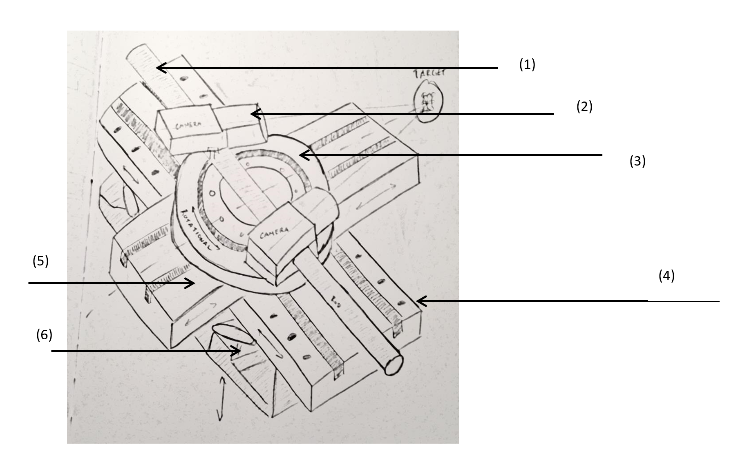

Figure 6 - Conceptual Manual Design

1) Camera Mounting Bar

2) Cameras

3) Rotational Stage For camera bar

4) Linear Translation Stage

5) Linear Translation Stage

6) Vertical Translation Stage

The next step in the design process was to decide on the best design as a team. A decision matrix was used to make an unbiased decision based on the true merits of each design. Due to the modular nature of the design, with each stage having the ability to connect to any other stage, the decision matrix included a category for each component rather than the entire design. The team’s decision was in favor of the semi-automated design. Next, the team presented the three conceptual designs, highlighting the chosen design. With feedback from the client, Dr. Stebner and FA Buddy Haun, on their emphasized priorities and degrees of freedom needed in the design the team began the re-evaluation and a modified conceptual design. The finalized movement capabilities required for this project, as agreed upon by Finesse DIC, the client, and the FA can be seen in Table 1 – Movement Requirements. This clarification allowed the team to simplify the design and remove unnecessary course translation and rotation stages.

After creating an accurate list of degrees of freedom and range of motion required by the project, the team held a second brainstorming session to modify the design to fit the clarified requirements. The new design had the additional capability of moving up and down on a large scale to move out of the line of x-rays directed at the sample. The x-rays being shot are located at Argonne Labs, a rented lab space utilized by the client, Dr. Stebner, for additional research. The x-rays are outside the scope of the project but needed to be avoided for the safety of the client and to collect quality, useful data. Upon further reflection of the constraints, the team also eliminated all the course stages except in the vertical direction because they were unnecessary to execute a calibration or collect data. The design is pictured in Figure 7 - Intermediate Design for Next Steps Letter.

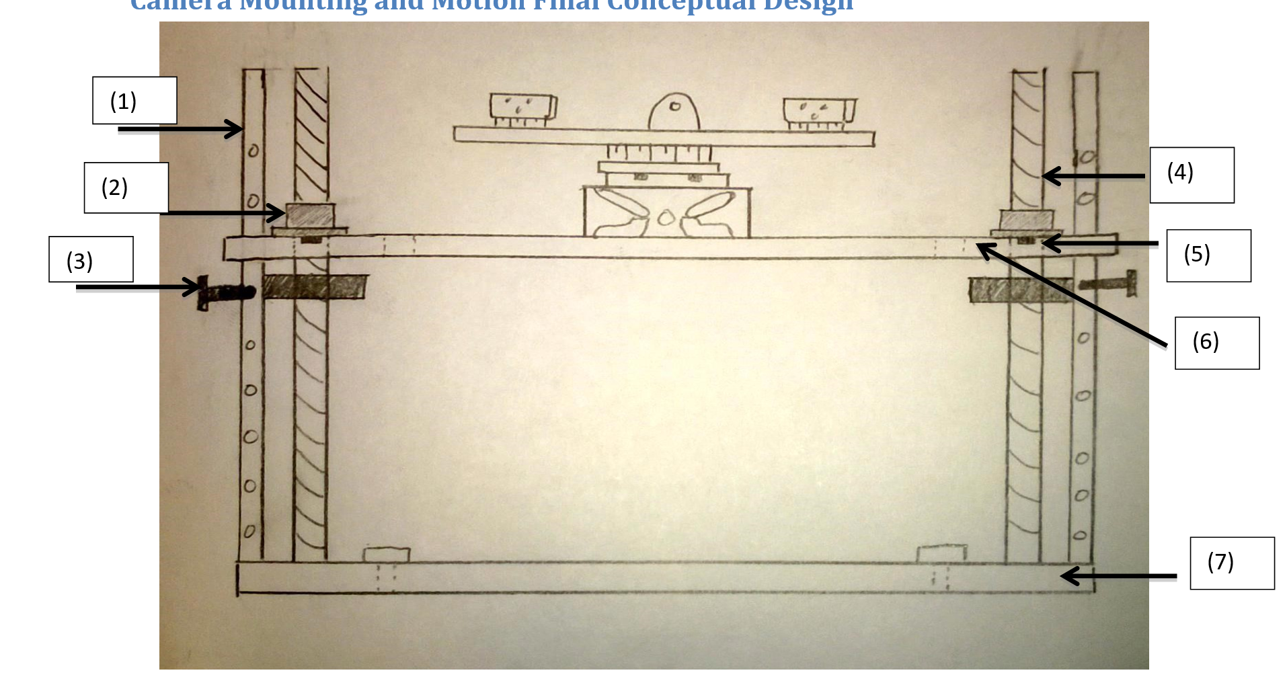

Figure 7 - Intermediate Design for Next Steps Letter

1) Struts

2) Ball Nut

3) Peg for fail-safe stop mechanism

4) Ball Screw

5) Pin for ball screw stop mechanism

6) Motion Plate

7) Base Plate

The calibration target design was also modified and reduced to only the necessary degrees of freedom and range of motion. The following picture in Figure 8 - Final Calibration Target Design demonstrates the redesigned calibration target. It is also the final conceptual design of the calibration target. The parts list in Table 10 – Final Parts List and the drawings in the Appendix H outline the final cost, part numbers, and dimensions of the design.

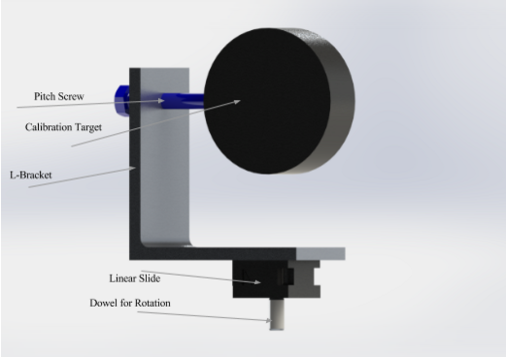

Figure 8 - Final Calibration Target Design

The team left of the first semester of the project with the next steps letter that outlined the schedule and plan leading forward through the end of the project. This letter included the modified designs seen above and the schedule that is included in the Appendix A.

Starting the second semester, the team reconvened with a meeting with the client, Dr. Stebner to verify the status of the project and the plan to close out the semester. The team was informed of changes to the layout of the test room in Argonne Labs. This change required additional modifications to the design shown in Figure 7 - Intermediate Design for Next Steps Letter. The modifications, however were put on hold until official specification of the layout of the lab and the space available for the design were provided. A visual representation of the Argonne Labs layout is presented in Appendix F.

With the drawings of the space available, it was clear that a horizontal stage would be necessary, rather than the rotational or vertical that were considered by the team for solutions to the x-ray beam. To fit this requirement, the team needed to make additional modifications to the design. The modifications are outlined in detail in the engineering analysis, along with the calculations required to ensure the viability of the design. To find the length of actuator needed to fit in the space available at Argonne labs, a model of the design was built in solidworks. All components had CAD downloads provided or the team created a model of the component from the drawings provided to ensure correct sizing of all components and accurate mass for calculations.

The next task was to determine the actuator that matched the needs of the project best. The criteria for choosing the horizontal stage actuator were:

1. Strength
2. Travel length
3. Cost

Each of these considerations is outlined in the calculations in Appendix D, Appendix F, and Appendix B respectively.

After carefully considering the options for the actuator and reviewing all engineering calculations with the client, all components were ordered and machined to create the built final design. As the parts came in they were verified to be the correct part, and built to verify their functionality. This build ensured that there was enough time to correct any errors in the design before the project was concluded. During the build there were only two errors found in the design, and both could be fixed before the conclusion of the project. These corrections were, a new translation stage in the calibration target, and an adapter to connect the lights to the camera mounting board.

With these small modifications the design was ensured to work properly and the project was handed off to the client for use in both the CSM Solid Mechanics Lab and Argonne Laboratories for research into new materials.

# 3. Engineering Analysis

As outlined in the project review, Finesse DIC was tasked with creating a mechanism for the calibration of strain cameras, which will interface with three separate load frames. There are two separate sets of strain cameras that are utilized, each a slightly different size. The camera mounting system is required to interface with each set of cameras seamlessly, and therefore must be toleranced appropriately. In addition, all components of the camera mounting system and calibration target are required to be optically toleranced to ensure accurate data can be gathered. Through the project iteration process displayed in Figure 1 - Engineering Design Process and extensive engineering analysis, Finesse DIC has created and built the final design, which meets all requirements of the client.

## 3.1 Project Constraints

To accurately design and test the camera mounting systems and calibration target, two sets of constraints were utilized. The first set of constraints is required movement capabilities of each mounting system and the calibration target, summarized in Table 1 – Movement Requirements. The second sets of constraints are the tolerances to which each component needed to adhere to, summarized in Table 2 - Tolerance Requirements. In order to sufficiently analyze each component the machined tolerances, deflection, repeatability, force, torque and moments were assessed. Each component for the camera mounting system is labeled in Figure 9 - Mounting System Component Labels, and will be referred to by component number. Similarly, each component for the calibration target is labeled in Figure 10 - Final Calibration Target Design with Labels and will be referred to by component number.

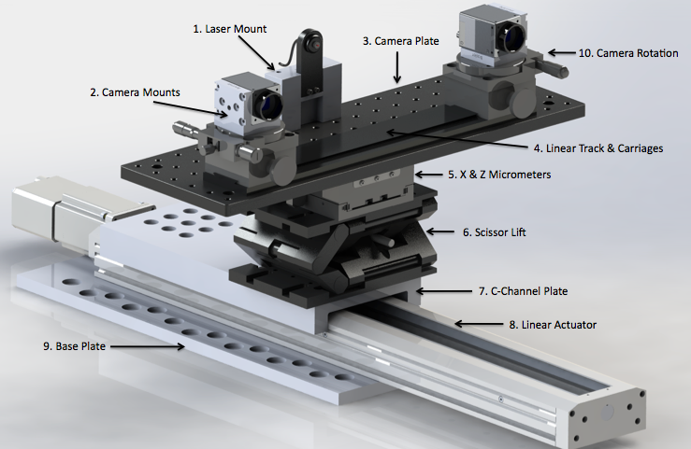

Figure 9 - Mounting System Component Labels



13.

12.

11.

Figure 10 - Final Calibration Target Design with Labels

Table 1 – Movement Requirements

|  |  |
| --- | --- |
| **Camera Mounting System** | |
| Camera Rotation | (+/-) 180 degrees |
| X - Direction | (+/-) 1 inches |
| Z - Direction | (+/-) 1 inches |
| Y - Direction | (+/-) 1 inches |
| Actuator Capability (Argonne Labs) | 12 (+/-) 1 in. / >18.2 in. from load frame |
| Required Camera C-Line Height (CSM Uniaxial) | 7.2 inches |
| Required Camera C-Line Height (CSM Biaxial) | 19.0 inches |
| Required Camera C-Line Height (Argonne Labs) | 11.7 inches |
| **Calibration Target** | |
| Rotation about X - axis | (+/-) 15 degrees |
| Rotation about Y - axis | (+/-) 45 degrees |
| Z - Direction | (+/-) 1 mm |

Table 2 - Tolerance Requirements

|  |  |
| --- | --- |
| **Camera Mounting System** | |
| X-Direction | (+/-) 0.5 micron |
| Y-Direction | (+/-) 0.5 micron |
| Z-Direction | (+/-) 0.5 micron |
| Pitch/Yaw | < 8 microns |
| Actuated Repeatability | < 2.5 micron |
| **Calibration Target** | |
| Rotation about X-axis | continuous |
| Rotation about Y-axis | continuous |
| Z-Direction | (+/-) 0.5 mm |

## 3.2 Load Frame Interface Requirements

The camera mounting system is required to interface directly with three separate load frames, as shown in Figure 11 - Uni-axis Load Frame, Figure 12 - CSM Dual Axis Load Frame, and Figure 13 - Argonne Labs Dual Axis Load Frame. In order to appropriately meet the focal point requirements, the movement capabilities outlined in Table 1 – Movement Requirements must be met for each specified configuration.

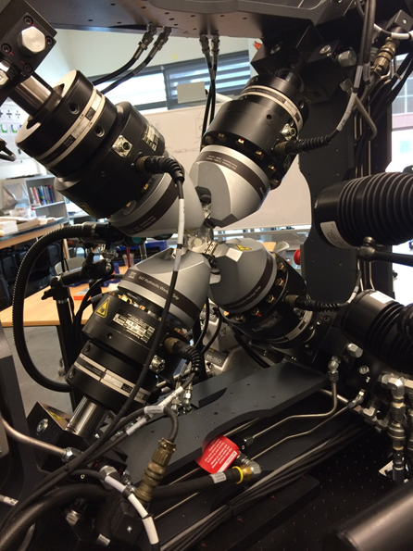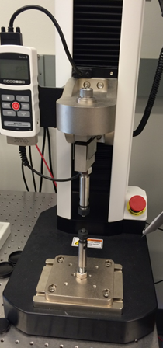

Figure 11 - Uni-axis Load Frame

Figure 12 - CSM Dual Axis Load Frame

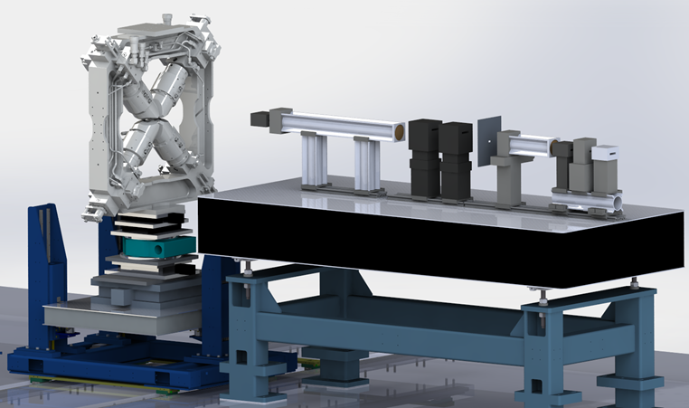

Figure 13 - Argonne Labs Dual Axis Load Frame

For the Argonne Labs load frame, the camera mounting system must have the capability to extend towards the load frame to the appropriate focal length, and retract away from the load frame, to a point outside of the designated circle of motion, represented from a top view in Figure 14 - Swept Circle of Dual Axis Load Frame Motion.

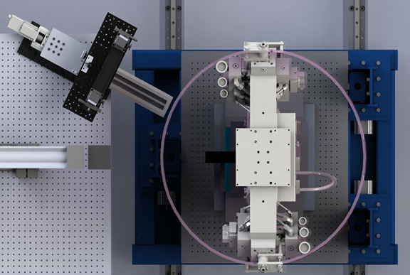

Figure 14 - Swept Circle of Dual Axis Load Frame Motion

## 3.3 Machined/Off-the-Shelf Tolerance Analysis

For all components, purchased or machined, a tolerance analysis was performed. In order to assure that all components were within the appropriate tolerances, all purchased parts were verified with the vendor prior to purchase. Not only this, each component was precisely measured upon receipt for verification. In the same way, appropriate machined tolerances were specified on all machined components. The tolerances for all off-the-shelf components can be found in Appendix H, in the Bill of Materials.

Components that required the most specified tolerances were components 1, 2, 9 and 10. Component 1, the laser block, allows for a faster and easier calibration using a laser as a centering point. However, if the laser does not align with the centerline of the camera, this calibration method is no longer useful. Therefore, the laser block must be machined with optical tolerances, as specified in Table 2 - Tolerance Requirements, and must appropriately align the laser with the centerline of each separate set of cameras. In a similar way, component 2, the camera mount, is required to be optically toleranced to interface exactly with both sets of cameras. This tolerancing includes perpendicularity and flatness to ensure that the cameras align exactly with the sample. For component 9, the angled base plate, the tolerancing must be precise in order to ensure that the alignment of the actuator is directly centered on the sample of Argonne Labs. This plate, pictured in Figure 31 - Angled Base Plate Hole/Angle Options has three separate sets of holes that are at a specific angle away from the center of the load frame. These angles allow the camera mounting system to not interfere with X-ray tube and spinning load frame, pictured in Figure 29 - Angled Base Plate Placement Analysis. Based on the criticality of the camera mounting system aligning directly with the center of the sample, as well as avoiding interference with the components in Argonne Labs, the tolerances of each angle must be within the tolerances specified in Table 2. Finally, component 10 requires a perpendicularity tolerance for the L-bracket, as well as parallelism and cylindricity for the screw hole that holds the calibration circle. These tolerances ensure that the calibration target is upright, and moves on axis for an accurate calibration. In order to ensure that all of appropriate tolerances are met, following the receipt of each item critical dimensions were measured and assembled for verification, and compared to the required dimensions. The machine drawings for each of these components can be found in Appendix H.

## 3.4 Deflection Analysis

In order to adhere to a deflection of < 8 microns, each component that could have a minor deflection was analyzed. This included components 3, 4, 7 and 8. Table 3 - Maximum Deflections summarizes the deflection results of each component. In order to fully analyze the deflection, the maximum static load that could be placed on each component was applied using SolidWorks Finite Element Analysis, with each component fixed as it would be when assembled. Each component was then analyzed to obtain the x-direction and z-direction deflection, and the worst case scenario was used.

Table 3 - Maximum Deflections

|  |  |  |  |
| --- | --- | --- | --- |
| **Component** | **Maximum Deflection** | **Maximum Von Mises Stress** | **FoS (VM)** |
| 3 | 6.25 micron (about z) | 450 psi | 9 |
| 4 | 0.65 micron (about z) | 250 psi | 13 |
| 7 | 7.35 micron (about x) | 475 psi | 7 |
| 8 | 0.08 micron (about x) | 123 psi | 18 |

As seen in the above table, the maximum deflection in any direction is on component 7, the C-Channel. The worst case scenario for the C-Channel is when it is fully extended C-Channel, with the weight applied by the components located on the furthest out hole. However, this deflection is still less than 8 microns, and therefore is acceptable provided that the sum total of the deflection remains below 8 microns. When the maximum deflection of component 7 and component 8 are combined, the total deflection still remains in the acceptable range.

Component 3, the camera plate, experiences the second most deflection. However, when the total deflection about the z-direction is summed, the maximum deflection remains below 8 microns, and therefore is acceptable.

To ensure the deflection analysis was adequate, a Von Mises stress analysis was completed in addition to the basic deflection analysis. This ensures that the materials selected have the appropriate rigidity to withstand continued use. The complete results of the Solidworks FEA can be seen in Appendix C.

There is also a buckling analysis to account for the use of stand rods in the second load frame configuration. This ensures that the mounting system still fits within all tolerance ranges. Through this analysis, the stand rods have been found to be fully acceptable for this application. The full engineering analysis is summarized in Appendix C.

## 3.5 Repeatability Analysis

The repeatability analysis is critical for component 8, the linear actuator. With appropriate repeatability, the actuator can be used for multiple cycles of samples without needing to be re-calibrated. In order to achieve this, a repeatability of < 5.0 microns is required. However, based on the precision required for an appropriate calibration, Finesse DIC determined a repeatability of < 2.5 microns is necessary. The actuator that has been selected has a repeatability of < 2.0 microns, and therefore is adequate. Specific values for the repeatability can be seen in the Bill of Materials, Appendix H.

## 3.6 Force and Torque Analysis

The force analysis was completed to ensure that the system would be able to withstand a small impulse force. A “small impulse force” can be classified as a person bumping into the side of the system. In order to verify this, the pre-existing static load from at risk components was subtracted from the maximum allowable force that each component could withstand. The minimum impulse force that could be applied to the system 14.85 lbf, applied to the rotational stages, component 10. In order to verify this was adequate, a series of torques, representing a hand resting on the system, a bump to the lenses, etc. were analyzed. The maximum force that resulted on component 10 was 7.8 lbf, resulting in a factor of safety of 1.9, and therefore is adequate. The full engineering analysis can be seen in Appendix D. However, in order to minimize the risk of such an impact, the Operator’s Manual has specified exact instructions on how to assemble camera mounting system, specifically the rotational stage, component 10. In addition, the Operator's Manual discusses appropriate handling of each component, and suggests that the system be kept in a safe space, away from walking traffic.

## 3.7 Moment Analysis

The final assessment of the camera mounting system and calibration target was the moment analysis, critical for components 7 and 8, the C-Channel and the linear actuator. This analysis is only valid for the third mounting system in Argonne Labs. The maximum moments applied by a static load was determined from a weight analysis of the final system, and analyzed using SolidWorks FEA. The full engineering analysis can be seen in Appendix E. The resulting maximum moment applied to component 8, the linear actuator, is 147 lbf*in. This results in a factor of safety of 1.8, and therefore is adequate.

## 3.8 Analysis Results

Based on the completion of a full engineering analysis, the final design of a camera mounting system and calibration target has been verified. The results have been shared with the client, and have been fully approved. The worst case scenario is tabulated in Table 4 - Worst Case Scenarios for Final Design (Tolerance Stack).

Table 4 - Worst Case Scenarios for Final Design (Tolerance Stack)

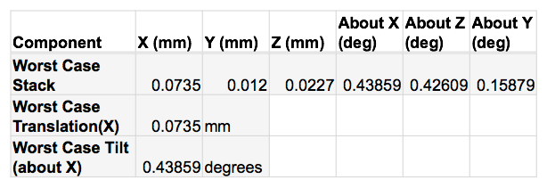

The final design, which meets all requirements outlined in Table 1 – Movement Requirements and Table 2 - Tolerance Requirements is pictured in Figure 15 - Uniaxial Load Frame Final Design and Figure 17 - Argonne Labs Load Frame Final Design. In addition, three videos included in the attached USB demonstrate the full range of motion of all components of the design.

## 3.9 Risk Mitigation

In addition to completing a full engineering analysis, Finesse DIC incorporated a Risk Mitigation process, seen in Table 5 - Risk Mitigation to verify all components of the design would remain functional. The Operator’s Manual addresses most aspects of this. However, this Risk Mitigation outline can be utilized for all future endeavors that utilize the same design.

Table 5 - Risk Mitigation

|  |  |  |
| --- | --- | --- |
| **Risk** | **Chance of Risk Occurring** | **Impact to Project Success** |
| Team Members' Safety (Pinch Points) | **Medium** | **Low** |
| Damage to Critical Components | **Low** | **High** |
| Finishing Project within Schedule | **Medium** | **High** |
| Error in Operation of Equipment | **Medium** | **Medium** |
| Defective Purchased Parts | **Low** | **High** |
| Machined Parts Outside of Requested Tolerance | **Low** | **High** |

# 4. Final Deliverables

The final deliverables of this project included a camera mounting system that can be adapted to three separate load frame configurations, as well as a calibration target that interfaces with the CSM owned uniaxial load frame, as seen in Figure 10 - Final Calibration Target Design with Labels. Based on the engineering design and analysis work that was completed, Finesse DIC is confident that the final designs meet the project requirements to the full extent. Through the camera mounting systems and calibration target, the team has created a mechanism that allows for a quick and complete calibration with any of the three separate load frames.

## 4.1 Camera Mounting Systems

Originally, Finesse DIC was tasked with creating a singular camera mounting system that can be adapted to interface appropriately with each load frame discussed previously. However, the appropriate documentation has been provided to enable The Beam Team to fully replicate each camera mount system to create as many of each separate configuration as desired. All camera mounting system configurations have both machined and off-the-shelf components, discussed in Section 4.3.

### 4.1.1 Camera Mounting System for CSM Uniaxial Load Frame

The first camera mounting system incorporates all the required motion capabilities discussed in Table 1 – Movement Requirements. It will be mounted directly in front of the uniaxial load frame on an optical table, with the centerline of the cameras no more that **7”** from the optical table’s surface. The mounting system can be bolted to the table as close or far from the load frame as desired to accommodate different lenses and enable the team to reach the appropriate focal length.

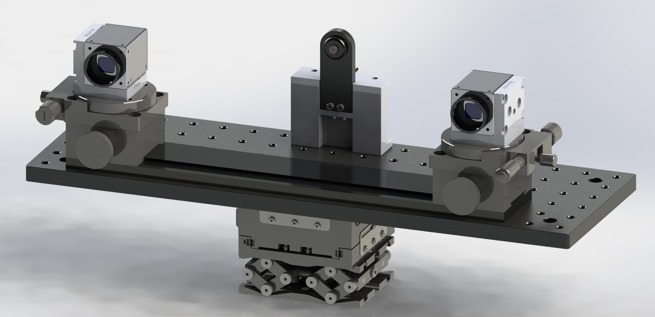

Figure 15 - Uniaxial Load Frame Final Design

### 4.1.2 Camera Mounting System for CSM Biaxial Load Frame

The second camera mounting system is identical to the first, aside from the utilization of a pre-existing scissor lift that The Beam Team currently possesses. Finesse DIC has utilized this scissor lift to minimize cost. However, the first camera mounting system can be used for the CSM Biaxial Load Frame with no complications if necessary. The only differing requirement is that the centerline of the camera is required to be 19”from the optical table’s surface, rather than 7. If the appropriate height is not attained by the first mounting system, optical stand rods may be placed underneath the system to add the required height addition.

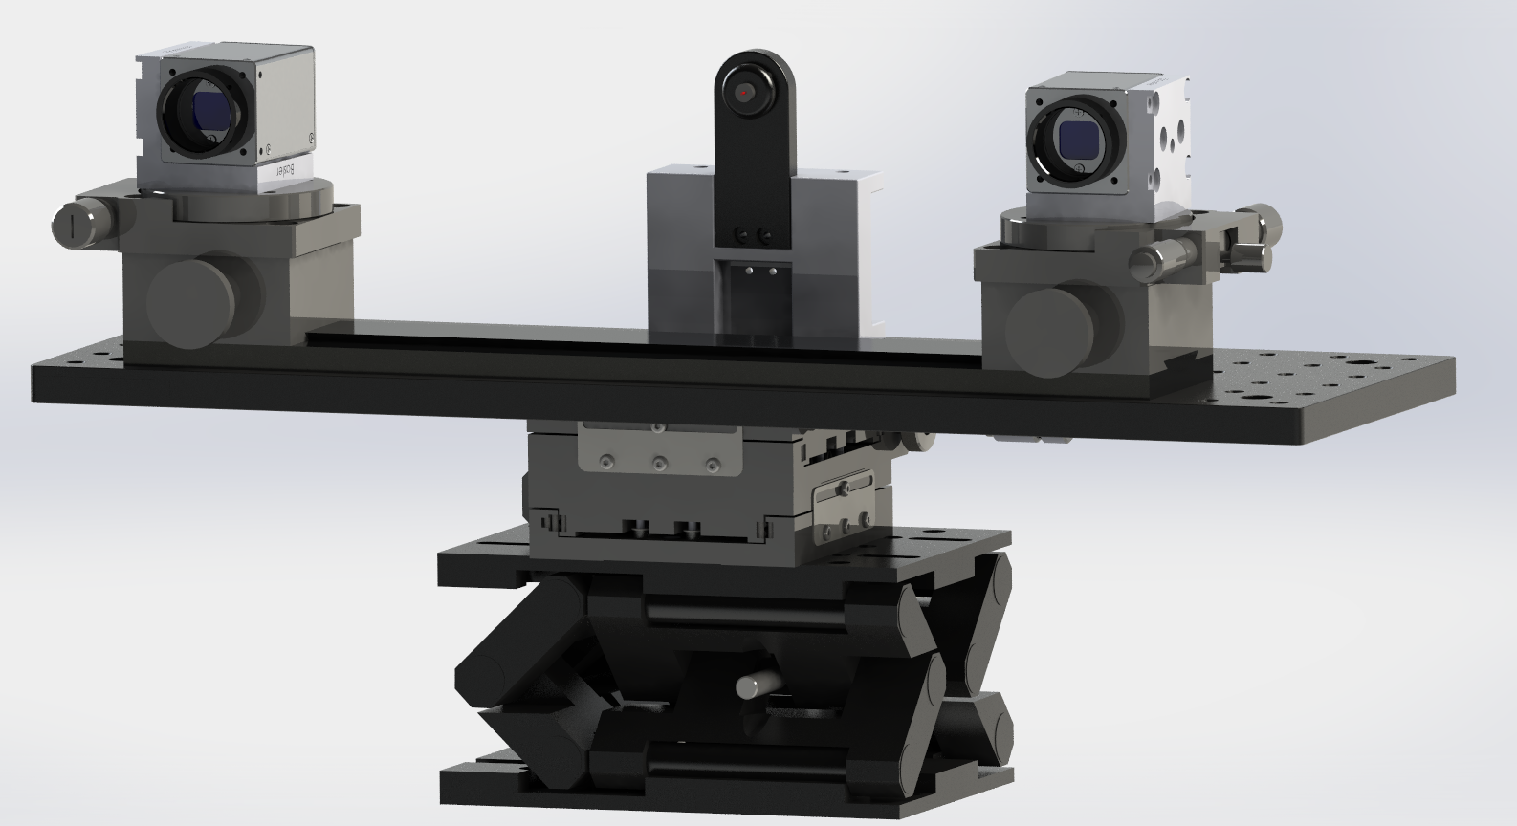

Figure 16 - CSM Dual Axis Load Frame Final Design

### 4.1.2 Camera Mounting System for Argonne Labs Biaxial Load Frame

The Argonne Labs Biaxial Load frame incorporates many other outside components that the Finesse DIC team had to account for such as X-Rays and a spinning load frame. All of the appropriate engineering calculations and analysis have been completed in Section 3.

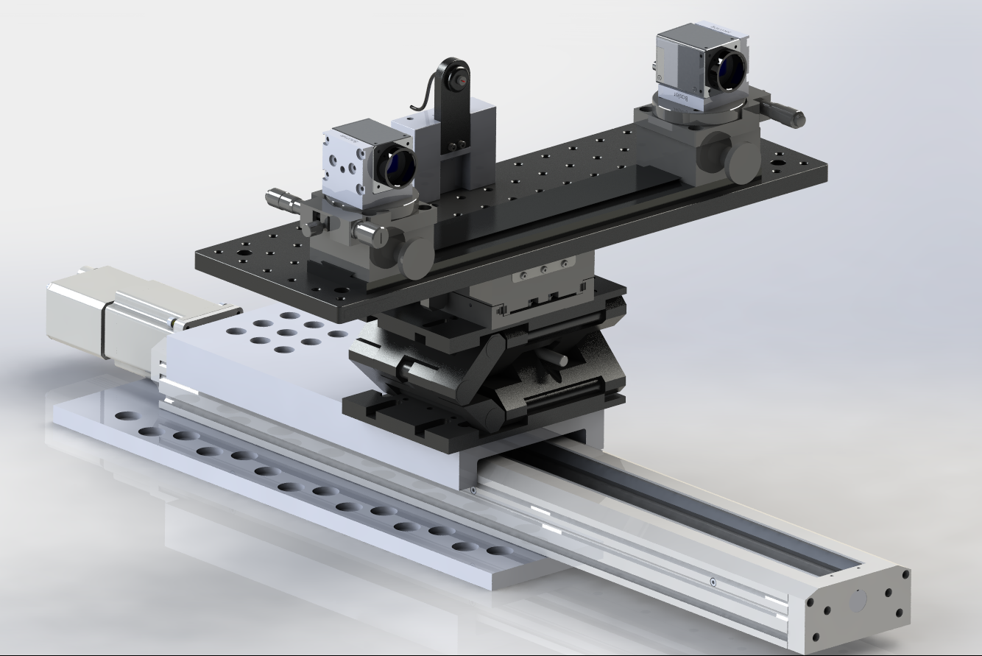

Figure 17 - Argonne Labs Load Frame Final Design

This third camera mounting system is identical to the first, but utilizes two additional mounting plates and an actuator to reach the appropriate focal point. The actuator allows the entire camera mounting system to move inwards to the appropriate focal length, and outwards to remove it from interfering with a rotating load frame Figure 14 - Swept Circle of Dual Axis Load Frame Motion. All actuator controls are programmed through Zaber and can be controlled from outside of the lab, allowing for the safety of those operating the research equipment. This mounting system is to be mounting at specific locations on the optical table in Argonne Labs in order to achieve the appropriate result and have the cameras directly centered on the load frame. Specific instructions on where this is to be placed are contained within the Operator's Manual at the end of this document.

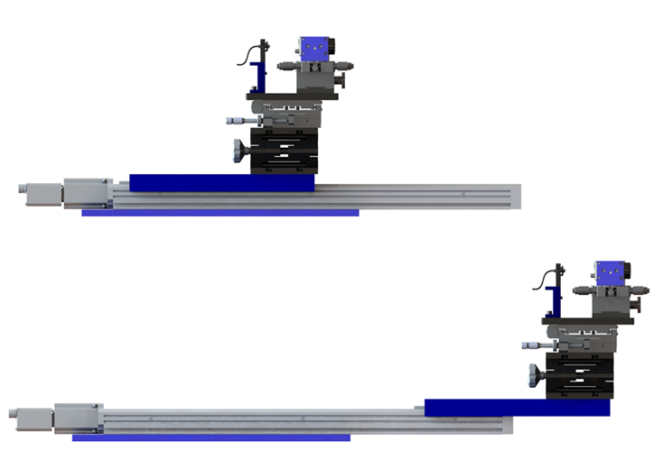

Figure 18 - Actuator Movement Capabilities

## 4.2 Calibration Target

The calibration target interfaces only with the CSM Uniaxial Load Frame. The required motion capabilities are outlined in Section 3. The calibration target drops into the caulet of the uniaxial load frame, where it can be manipulated appropriately in order to complete a fast and accurate calibration. Movement instructions are included in the Operator's Manual at the end of this document.

## 4.3 Bill of Materials/ Engineering Drawings

The Bill of Materials and Engineering Drawings required for replication of this project are included in Appendix C and D. These have been provided to enable The Beam Team to build separate mounting systems for each load frame, rather than a single mounting system that can be adapted to each load frame. These are also to be utilized to build camera-mounting systems for research that is to be completed for aerospace applications.

## 4.4 Operator's Manual

In addition to the Bill of Materials and Engineering Drawings, a full Operator's Manual has been provided at the end of this document for each mounting system and the calibration target. This allows for an easy transfer of information, and the assurance that all components of this system will last without damage for the full lifetime of the project.

## 4.5 Project Validation

The Finesse DIC team has met with the client numerous times to ensure that the project meets the requirements outlined in the original scope of the project. Through the engineering design and analysis work completed in Section 3, as well as a mock calibration utilizing all components, the client is satisfied that the project has been completed to its full extent.

# 5. Project Management

## 5.1 Work Breakdown Schedule

In Figure 19 - Work Breakdown Schedule an updated Work Breakdown Schedule for the project is shown, detailing all of the aspects of the project that have been completed. This enabled Finesse DIC to appropriately assign work to each team member, and complete all aspects of the project fully. All aspects of this project have been completed fully, with the work appropriately broken up between team members. For continuing work, Finesse DIC has provided the appropriate documentation (see Section 4.4) to fully replicate each camera mounting system. However, the project has been completed to its full extend as per the original scope.

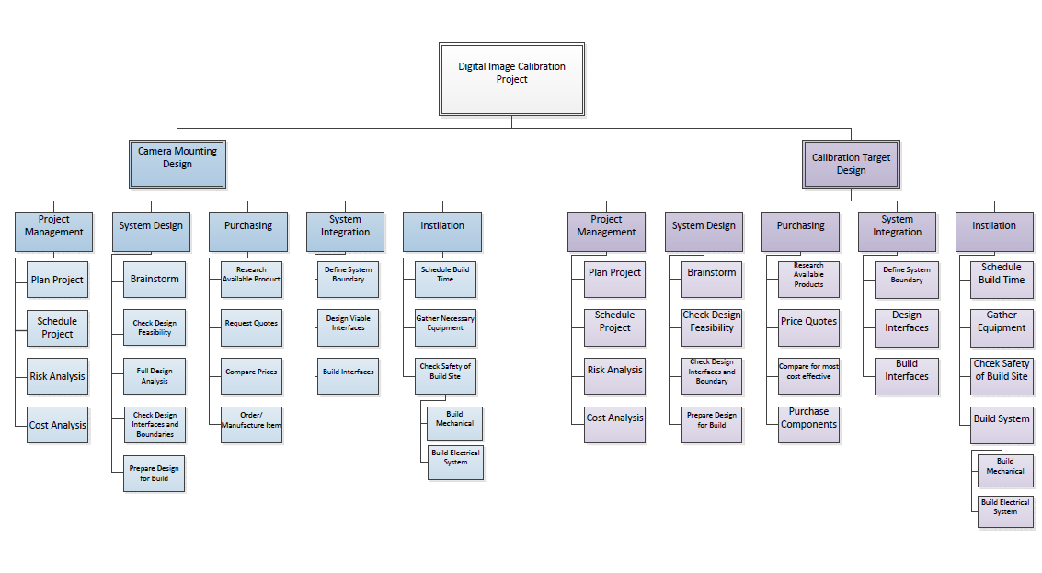

Figure 19 - Work Breakdown Schedule

## 5.2 Schedule

Finesse DIC has maintained an accurate schedule, which has enabled all aspects of the project to be completed on time, and with the allowance for any adjustments necessary. This can be seen in Appendix A. The result of this schedule is a fully completed mechanism that allows for a quick and consistent calibration of the strain cameras.

## 5.3 Budget

Finesse DIC has created a final budget that has been discussed and approved by the client, prior to the purchase and machining of all components. This budget has been reduced from an estimated $12,000 to $6,000. This reduction in budget resulted from the re-engineering and design of the most expensive components. Of these, the previously proposed actuator for the Argonne Labs configuration has been replaced with a simple, easily maintainable system, and far less expensive system. The new actuator has been verified in Section 3, and meets all tolerance requirements given by the client to a greater extent that the previously suggested system. In addition, Finesse DIC researched different machining options in order to maintain a low cost. This enabled Finesse DIC to provide a final project that was well under the original budget, and provide a quality product for the client.

## 5.4 Outstanding Work.

All work on the project is complete with one small exception. The interface between the lights and the small camera breadboard is not perfectly compatible. An adapter must be purchased to convert the M8 to a ¼”-20 thread to interface with the English breadboard. A female M8 to a male ¼”-20 must be purchased.

Retailer: <http://www.adorama.com/>

Manufacturer: WindTech.

Product number: SKU: WTM8 MFR: M8

Product name: WindTech M-8 3/8"-16 Female to 1/4"-20 Male Thread Adapter

# 6. Lessons Learned

The team’s definition of a good design remained consistent throughout the duration of the project. A good design was defined as a design that most efficiently meets the needs the client. A good design will also be verified by accurate and thorough engineering calculations, and will be safe and cost effective. The design itself changed throughout the project however the goal of the project and what makes a design good did not. The changes of the design and the iterations are illustrated in the design methodology section.

If the team were to execute this project again, some of the things to do differently include: thoroughly verifying the scope of the project, verifying all of the constraints. The team would verify the scope by asking more questions to formulate a clear written understanding by the team. Then, present the understanding to the client to verify that the team had the correct understanding of the scope and project before starting detailed engineering work on the project. The team would verify the constraints of the project in a similar manner. These methods differ in what the team did during this project by the timeframe in which they occurred. In the actual project they occurred later than the team would have liked, and the project would have occurred more smoothly if they had occurred sooner. If these changes were to occur, the team would have understood the scope very well at the very beginning of the project and could have caught and avoided potential scope creep in the project.

A lesson learned in teamwork during this project has been the need to draft a contract at the very beginning of the project. The need for a contract to outline the responsibilities of each member such as timeliness, the quality of work expected, and the time commitment needed were all elements with an assumed value that differed between each team member. If these values had been discussed at the beginning of the project in a contract, many conflicts between team members could have been avoided. The contract would have clearly stated how much each team member was expected to contribute and a process put into place on how to address underperforming team members. Thus, no team member could feel that they were being treated unfairly if each expectation and punishment were outlined before the project began. The contract could also eliminate the team’s problem with unexcused absences from team meetings because it would outline a procedure to remediate the problem involving the FA and other course staff. With these procedures in place the workload between team members would be much more equal, and it would make the project more efficient.

Specific aspects of this project proved more challenging than the team expected, such as the time required to document the design process, and verifying that proper equipment was available to complete tasks. Without thoughtful budgeting of time at the beginning of each week, it becomes easy to forget to allocate time to proper documentation of the design process and creating documents and presentations. If the time spent preparing and giving presentations is not accounted for it is easy to fool oneself into thinking that there is more lab hours reserved for analysis and engineering design than are actually available and deadlines can sneak up quickly. The same conundrum can occur with preparing reports, they are useful checkpoints in the design process to evaluate progress, but the time it takes to prepare them must be properly allocated as to not lose productivity to create the document.

The second lesson learned was to verify that proper equipment is available to use. This was a lesson learned when using the machine shop to machine the necessary parts for the design. It was taken for granted that the proper equipment would be available when dimensioning the parts to be machined. The parts were dimensioned in metric units, however all the equipment available was in English units, so values had to be converted during machining. If the team had taken the time to verify the equipment before it needed to be machined, the process would have been much smoother. Additionally, the capabilities of the calibration target were not fully verified before ordering components. Consequently a part was ordered that did not fully meet the needs of the client. This resulted in the need to order a replacement part, and redesign one other part so the design could meet the client’s needs. With the chance to do it over, the team would have confirmed in more detail that the design met the needs of the project before proceeding. This would make the process more time efficient and cost efficient to both the team and the client.

In conclusion, there were many lessons learned in the senior design project about effective teamwork, planning ahead, and the amount of analysis needed for an effective project. The lessons learned in this project have taught all the team members valuable project skills that can be transferred to future projects in future careers. The skills learned about effectively working in a team will be important in all career paths, as well as the ability to accurately schedule and budget a project will be necessary in all future projects. While the direct knowledge acquired from the project may not be transferable the skills of analysis, time management, forecasting, and scheduling will be useful for years to come.

Appendix A: Schedule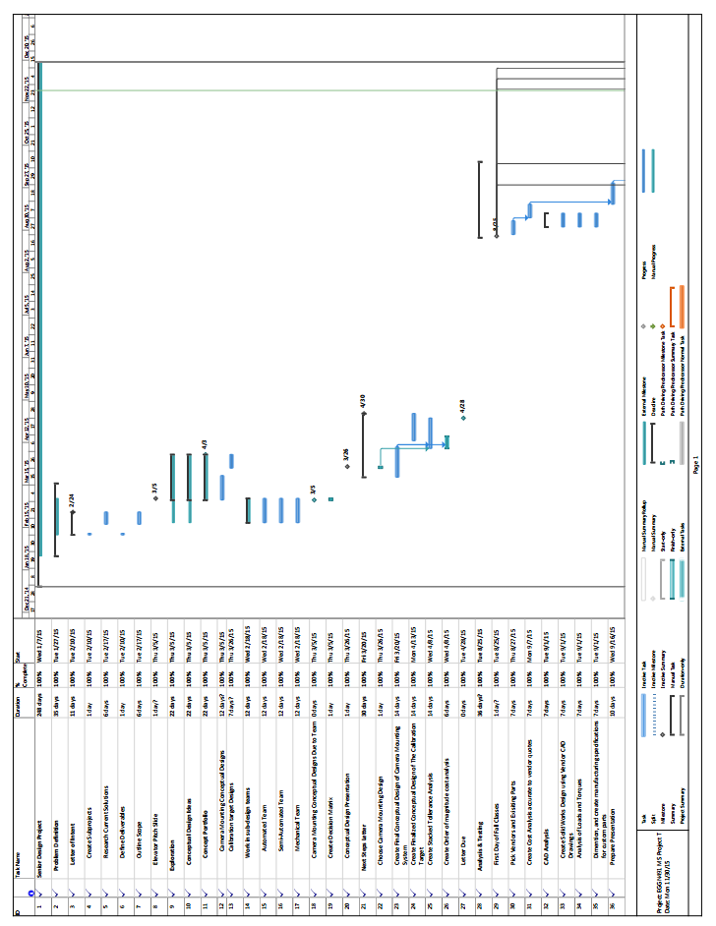

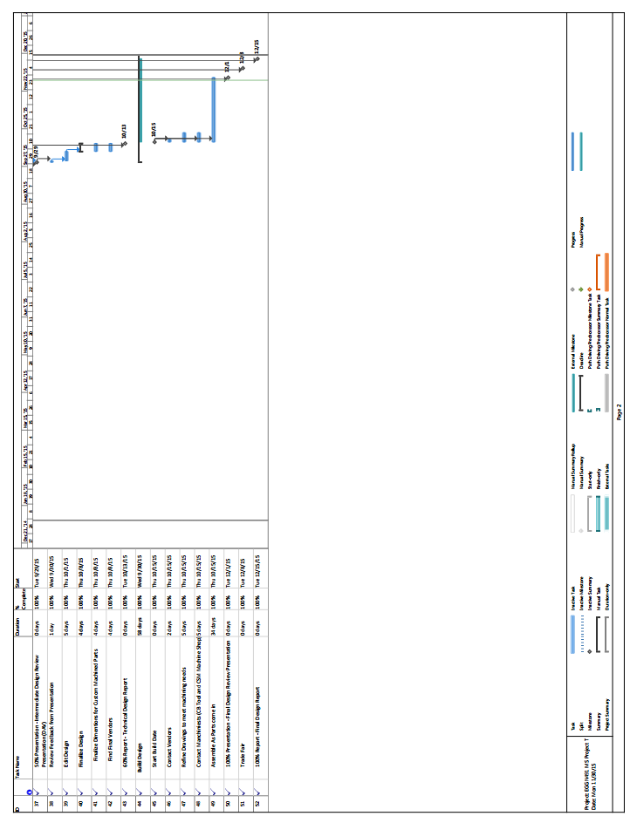

# Appendix B: Preliminary & Final Budget

Table 6 – Preliminary Budget

|  |  |  |  |  |  |
| --- | --- | --- | --- | --- | --- |
| **Category** | **Component** | **Quantity** | **Cost** | **Shipping** | **Total** |
| Machined | Camera Bracket | 2 | $300.00 | $100.00 | - |
| Laser Mount | 1 | $200.00 | - |
| Cantilevered Camera Plate | 1 | $200.00 | - |
| Actuator Base Plate | 1 | $250.00 | - |
| Calibration Target Bracket | 1 | $25.00 | N/A | - |
| Calibration Target Pillow Block | 1 | $25.00 | N/A | - |
| **Machined Subtotal** | | | | $1,100.00 |
| Purchased | Camera Theta Rotation | 2 | $300.00 | $30.00 | $630.00 |
| Camera X Translation Track | 1 | $242.25 | $24.23 | $266.48 |
| Camera X Translation Carriage | 1 | $99.00 | $9.90 | $108.90 |
| Bread Board for Camera Plate | 1 | $120.00 | $12.00 | $132.00 |
| Small Bread Board for Mounting | 1 | $48.00 | $4.80 | $52.80 |
| Linear Actuator | 1 | $5,525.00 | $552.50 | $6,077.50 |
| Linear Actuator Controls | 1 | $3,000.00 | $300.00 | $3,300.00 |
| **Purchased Subtotal** | | | | $10,567.68 |
| Project Subtotal | |  |  |  | **$11,667.68** |
| 10% Contingency | |  |  |  | $1,166.77 |
| **Project Total** | |  |  |  | **$12,834.44** |

Table 7 - Final Budget

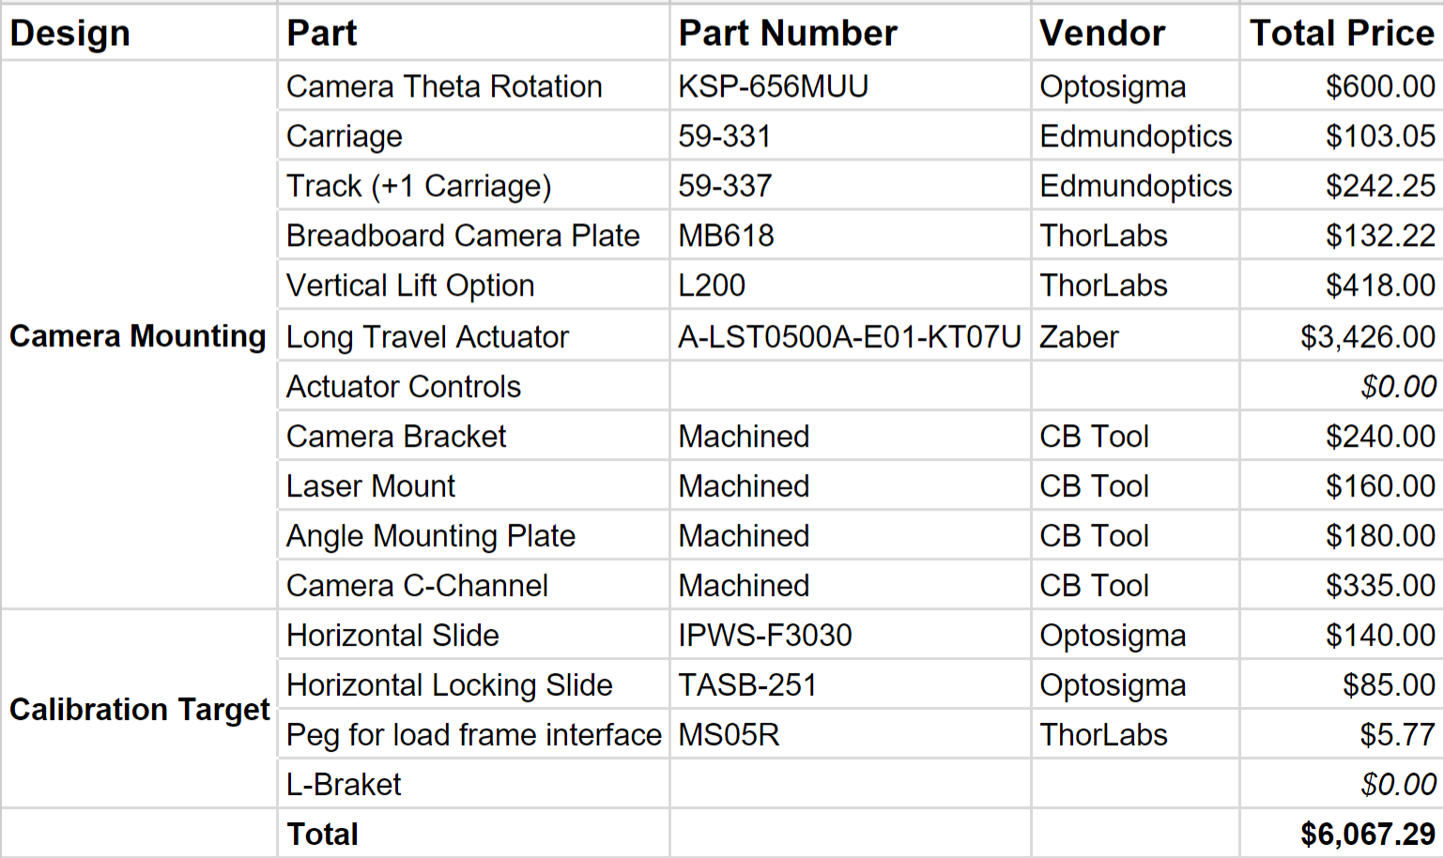

*Budget Updates:*

Throughout the year long process the budget for this project changed significantly. The original project description gave the project team a budget of $2,000, with the option of expanding the budget to $8,000. The final cost of the project is of $6,000. There were many factors that contributed to this increase in cost from $2,000 to $8,000. The update in load frames altered the scope of the work, and therefore made the camera mounting system much more sophisticated. One large piece of equipment that contributed to the increase in price is the long travel actuator. This actuator is needed, for the dual axis load frame in Argonne labs, to retract the camera mount out of the way of the x-rays and the movement of the load frame. Originally an actuator was to be used that would push the budget to $12,000. However, through careful research and innovative design, Finesse DIC was able to create a final design for $6,000. Another large reduction in cost came as the project team discovered that the actuator travel controls could be configured in house with the help of another student researcher. The project team had originally estimated that the actuator controls would have costs $3,000, and with the help of the student researcher the actuator controls would not have contribute any cost to the project. This was done by getting the machined parts quoted by multiple machine shops and choosing the shop that could do the most efficient work. There were also off the shelf components that were compared amongst manufacturers to choose the most efficient pieces for our budget. The project team was also able to machine a couple of pieces themselves. This eliminated any cost that it would have taken for a machine shop to make these parts.

# Appendix C: Deflection Analysis

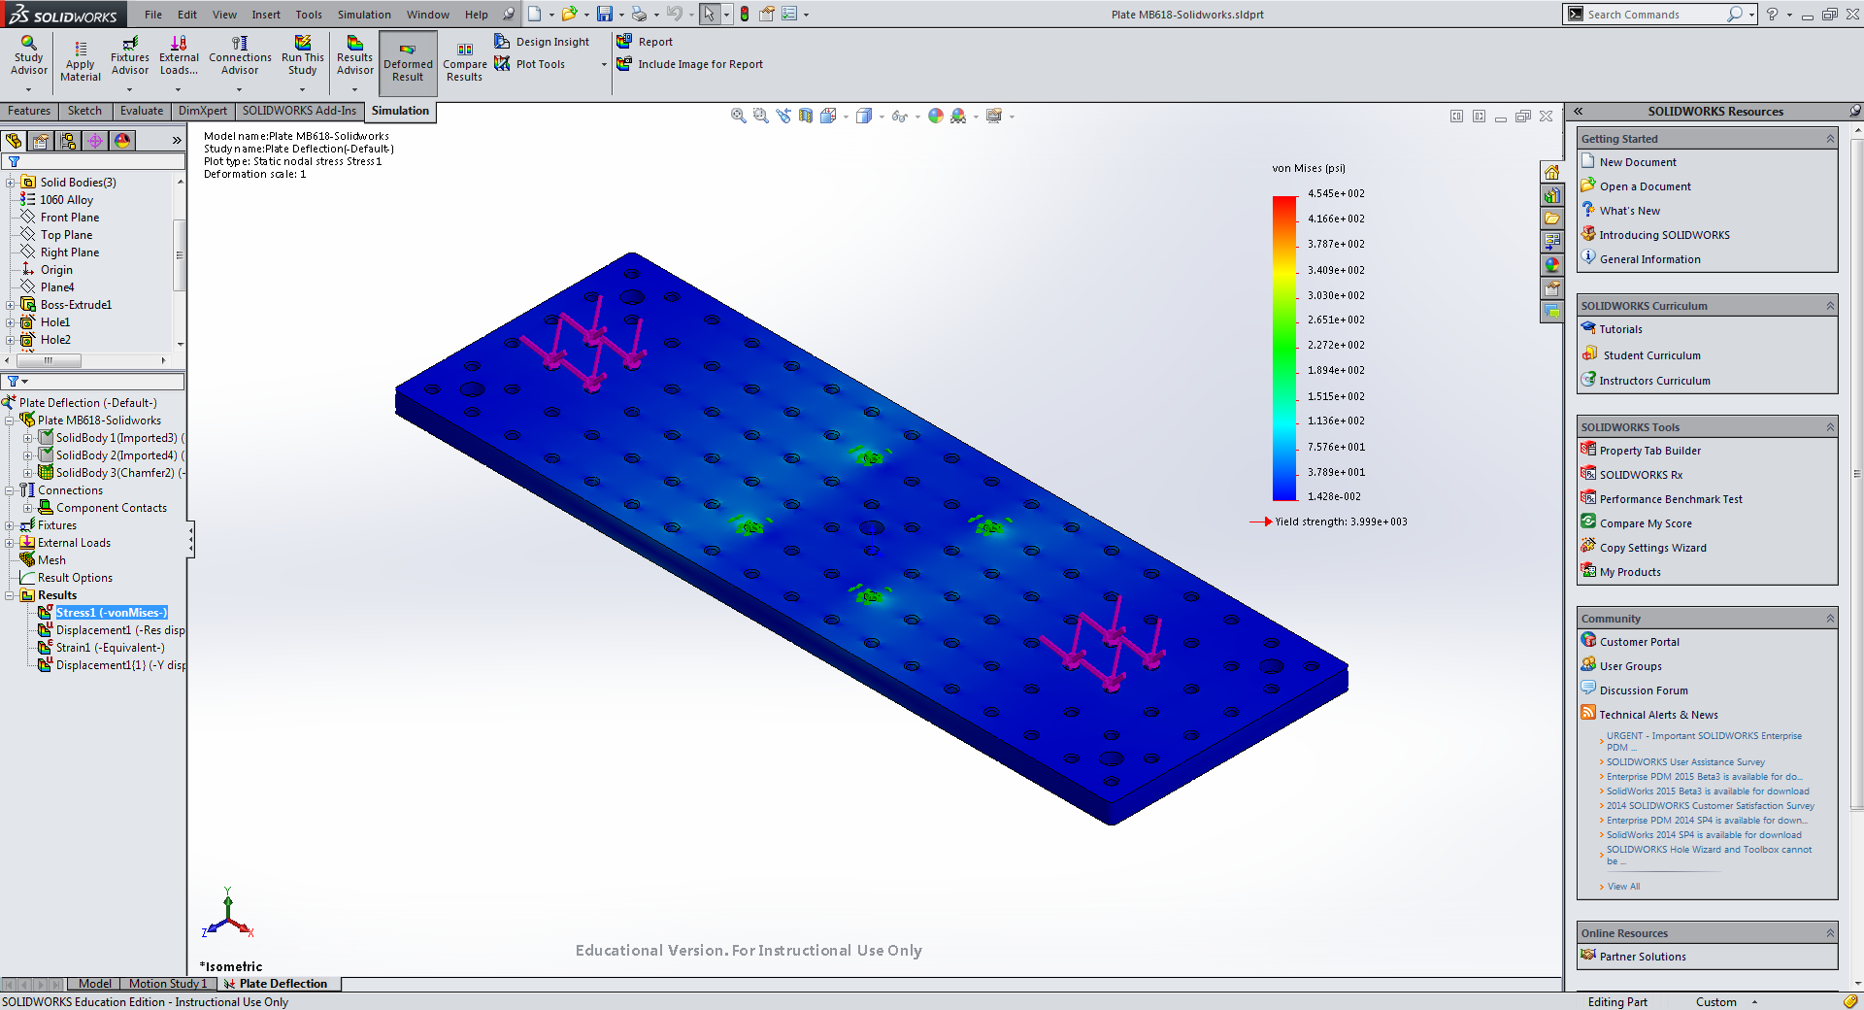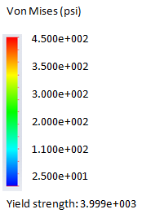

Figure 20 - Camera Plate von Mises Stress Analysis

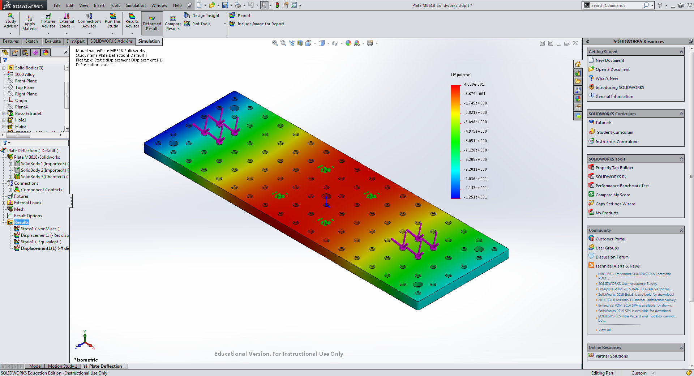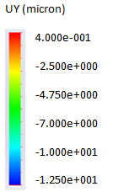

Figure 21 - Camera Plate Deflection (Y) Analysis

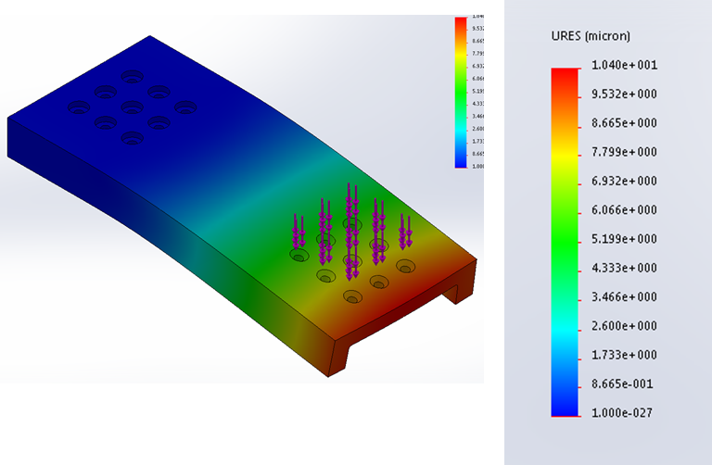

Figure 22 - C-Channel Deflection Analysis

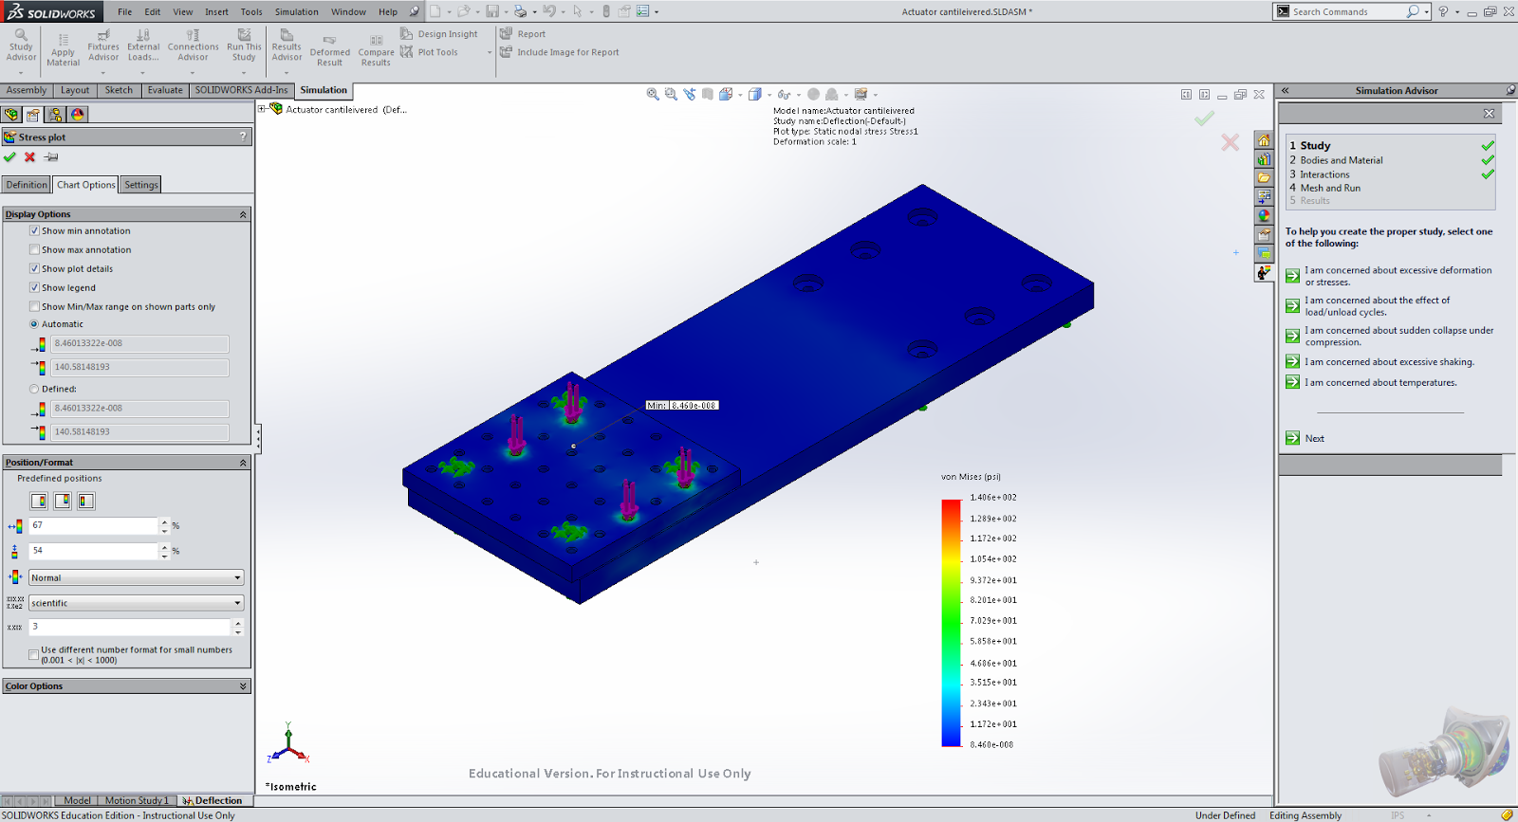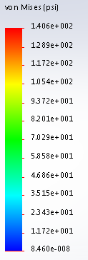

Figure 23 - C-Channel Von Mises Analysis

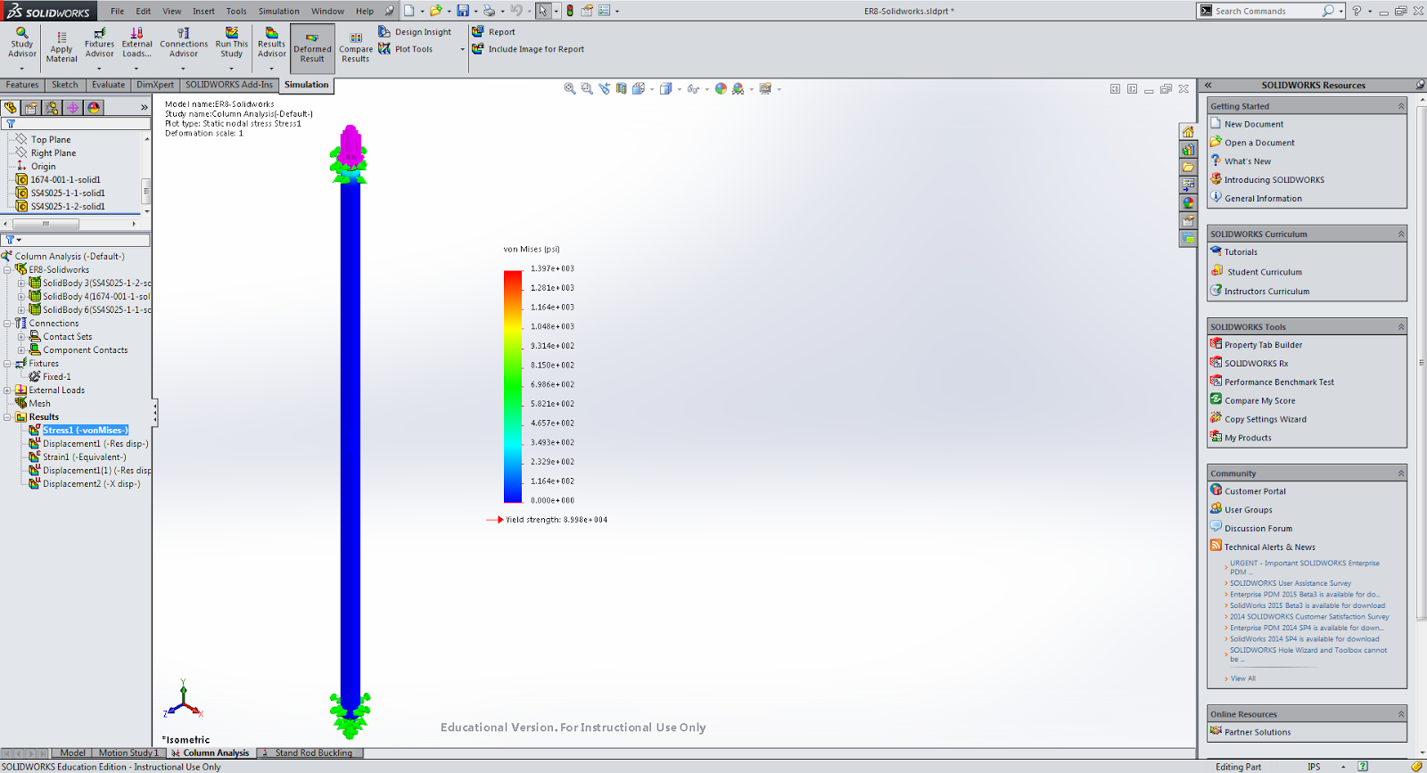 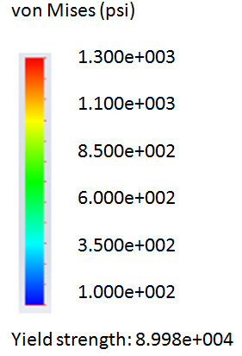

Figure 24 - Column Analysis Von Mises Stress Analysis

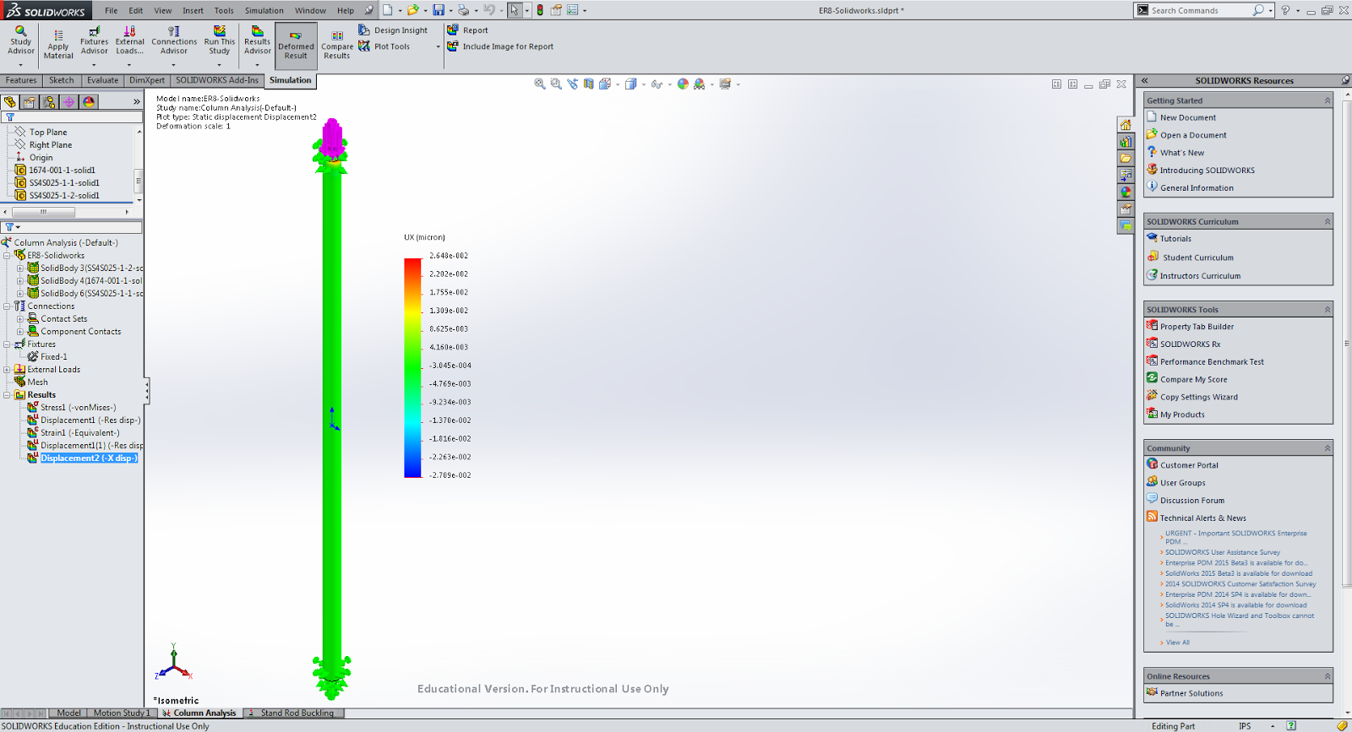 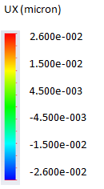

Figure 25 - Column Deflection Analysis

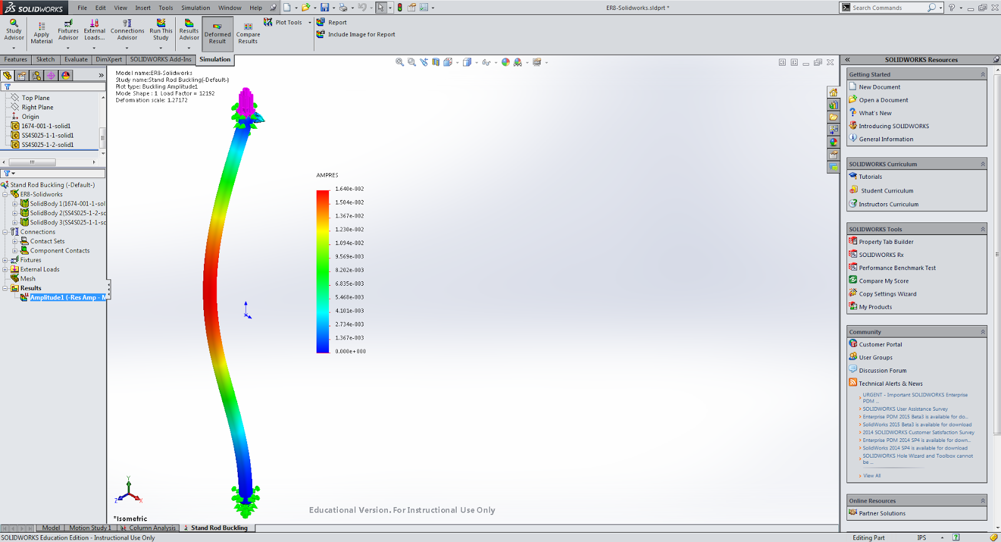 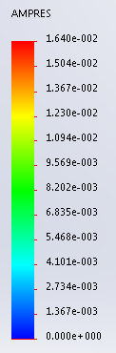

Figure 26 - Column Deflection Analysis

# Appendix D: Force & Torque Analysis

Table 8 - Load Capacity Analysis

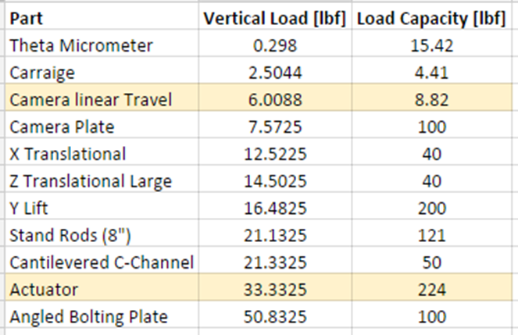

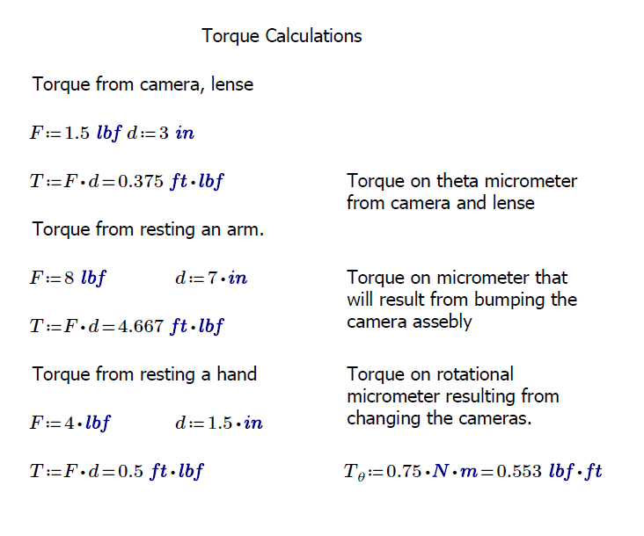

Figure 27 - Torque Calculations

# Appendix E: Moment Analysis

Table 9 - Total Weight Summation Applied to Actuator

|  |  |  |  |  |  |
| --- | --- | --- | --- | --- | --- |
| **Part** | **Weight [lbf]** | **Quantity [-]** | **Total [lbf]** | **Vertical Load [lbf]** | **Load Capacity [lbf]** |
| Baumer Camera | 0.5 | 2 | 1 | N/A | N/A |
| Lenses | 0.298 | 2 | 0.596 | N/A | N/A |
| Theta Micrometer | 1.54 | 2 | 3.08 | 0.298 | 15.42 |
| Carriage | 0.6664 | 2 | 1.3328 | 2.5044 | 4.41 |
| Rack | 1.3637 | 1 | 1.3637 | 6.0088 | 8.82 |
| Laser | 0.05 | 1 | 0.05 | N/A | N/A |
| Laser Block | 0.15 | 1 | 0.15 | 0.05 | 200 |
| Camera Plate | 4.95 | 1 | 4.95 | 7.5725 | 100 |
| X Translational | 1.98 | 1 | 1.98 | 12.5225 | 40 |
| Z Translational Large | 1.98 | 1 | 1.98 | 14.5025 | 40 |
| Scissor Lift | 4.65 | 1 | 4.65 | 16.4825 | 200 |
| Stand Rods (8") | 0.05 | 4 | 0.2 | 21.1325 | 121 |
| Cables, Bolts, etc. | 1 | 1 | 1 | N/A | N/A |
| **Total** |  |  | **21.3325** |  |  |

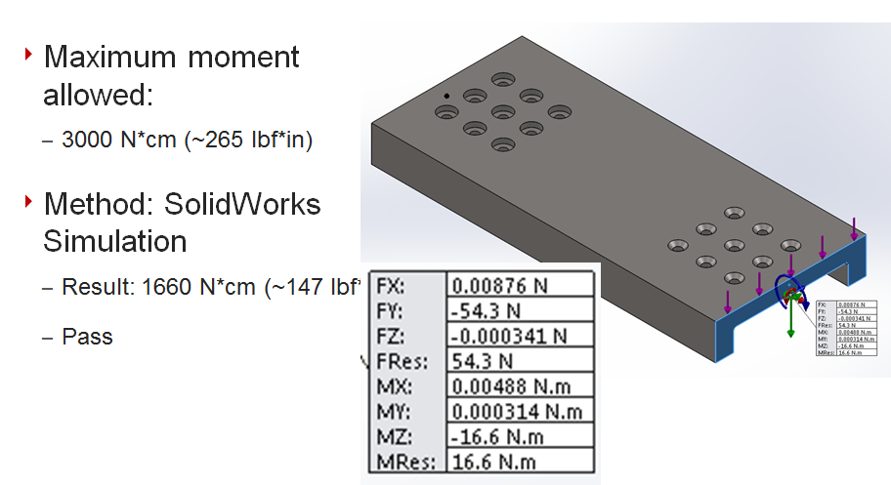

Figure 28 - Resulting Moment on C-Channel Analysis

# Appendix F: Angled Base Plate Calculations

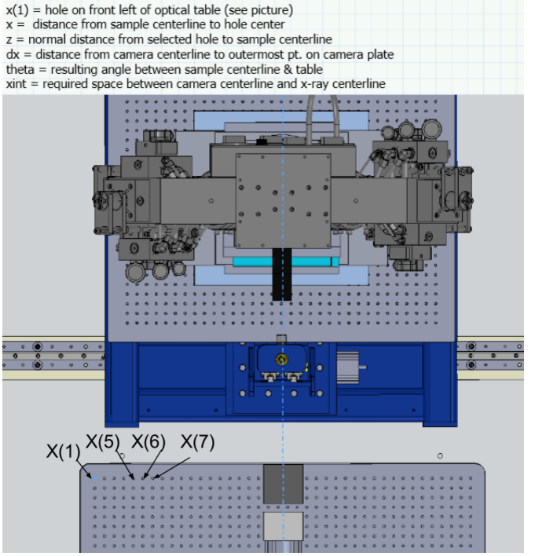

Figure 29 - Angled Base Plate Placement Analysis

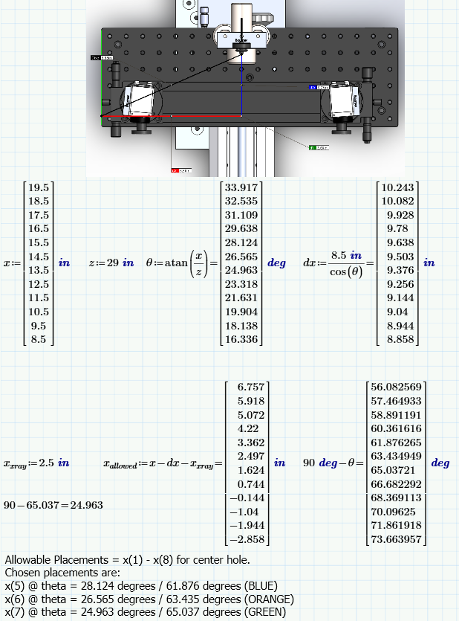

Figure 30 - Angled Base Plate Placement Analysis Cont.

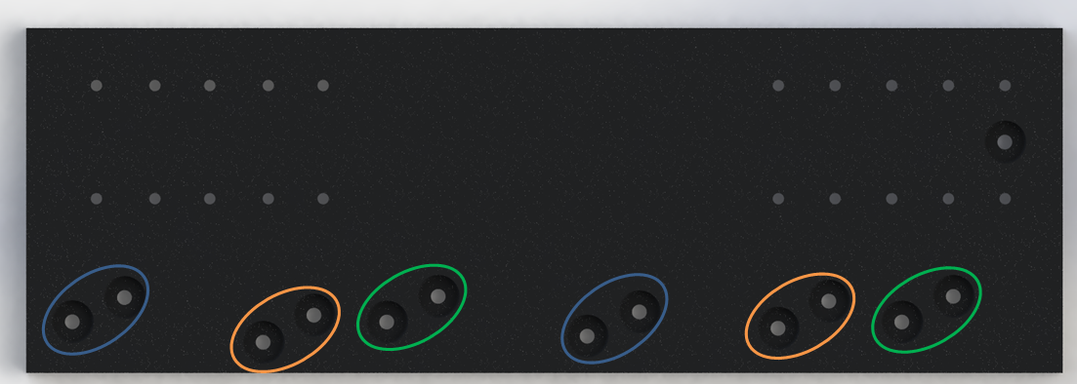

Figure 31 - Angled Base Plate Hole/Angle Options

# Appendix G: Final Parts List

Table 10 – Final Parts List

|  |  |  |  |  |
| --- | --- | --- | --- | --- |
| **Design** | **Part** | **Part Number** | **Vendor** | **Quantity** |
| Camera Mounting | Camera Theta Rotation | KSP-656MUU | Optosigma | 2 |
| Carriage | 59-331 | Edmundoptics | 1 |
| Track (+1 Carriage) | 59-337 | Edmundoptics | 1 |
| Breadboard Camera Plate | MB618 | ThorLabs | 1 |
| Vertical Lift Option | L200 | ThorLabs | 1 |
| Long Travel Actuator | A-LST0500A-E01-KT07U | Zaber | 1 |
| Camera Bracket | Machined | CB Tool | 2 |
| Laser Mount | Machined | CB Tool | 1 |
| Angle Mounting Plate | Machined | CB Tool | 1 |
| Camera C-Channel | Machined | CB Tool | 1 |
| Calibration Target | Horizontal Slide | IPWS-F3030 | Optosigma | 1 |
| Horizontal Locking Slide | TASB-251 | Optosigma | 1 |
| Peg for load frame interface | MS05R | ThorLabs | 1 |
| L-Bracket | Machined | CSM Shop | 1 |

# Appendix H: Bill of Materials

*Machined Components*

* Camera Bracket *Stock Material:* 6061 Aluminum Square Bar: 2”x2”x1’
* Laser Block *Stock Material:* 6061 Aluminum Flat Bar: 1”x3”x1’
* C-Channel *Stock Material:* Hot Rolled A36 Steel Plate: 1’x2’x¾”
* Angled Base Plate *Stock Material:* 6061 Aluminum Plate: 1’x2’x¾”
* L Bracket *Stock Material:* 6061 Aluminum Flat Bar: 1”x3”x1’

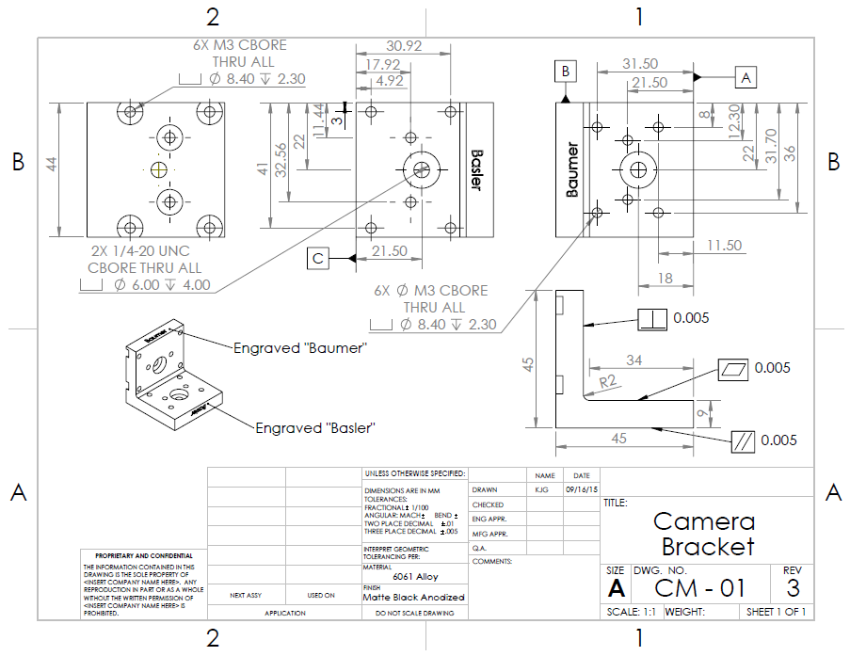

Figure 32 - Camera Bracket

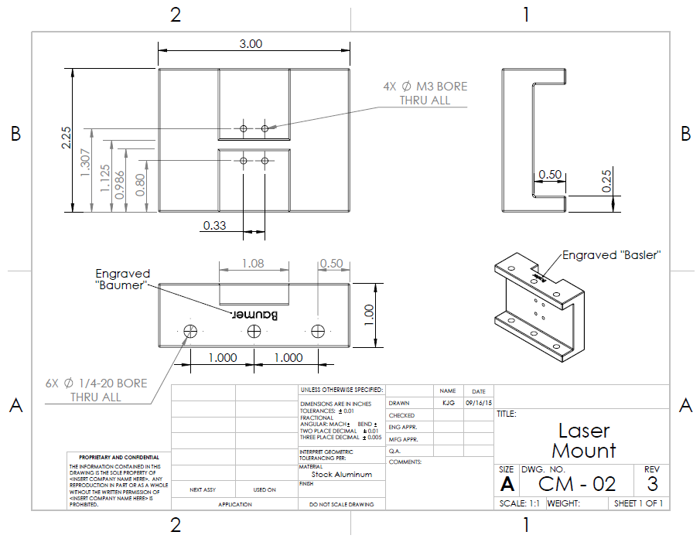

Figure 33 - Laser Mount

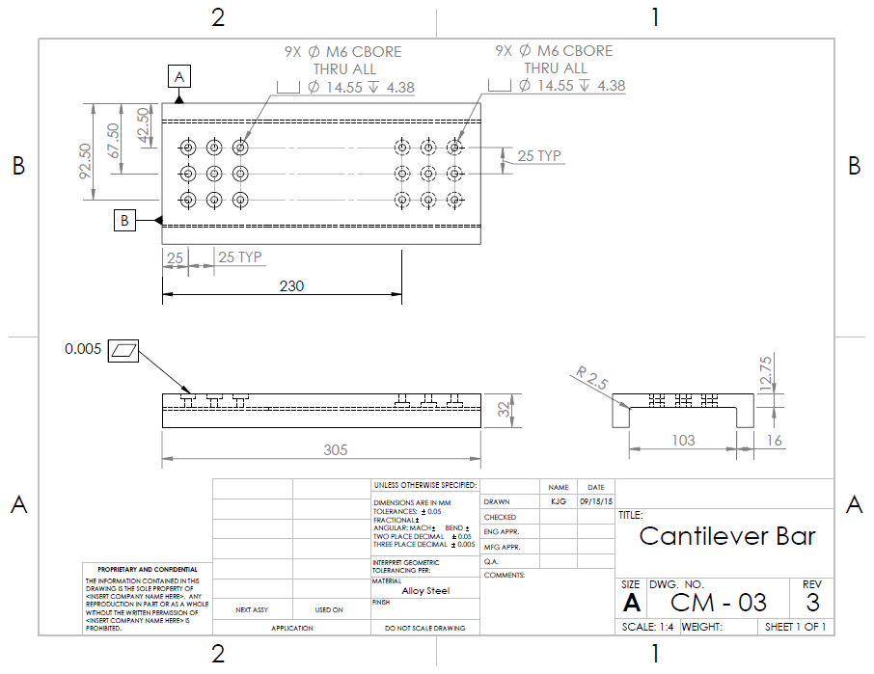

Figure 34 - Cantilever Bar (C-Channel)

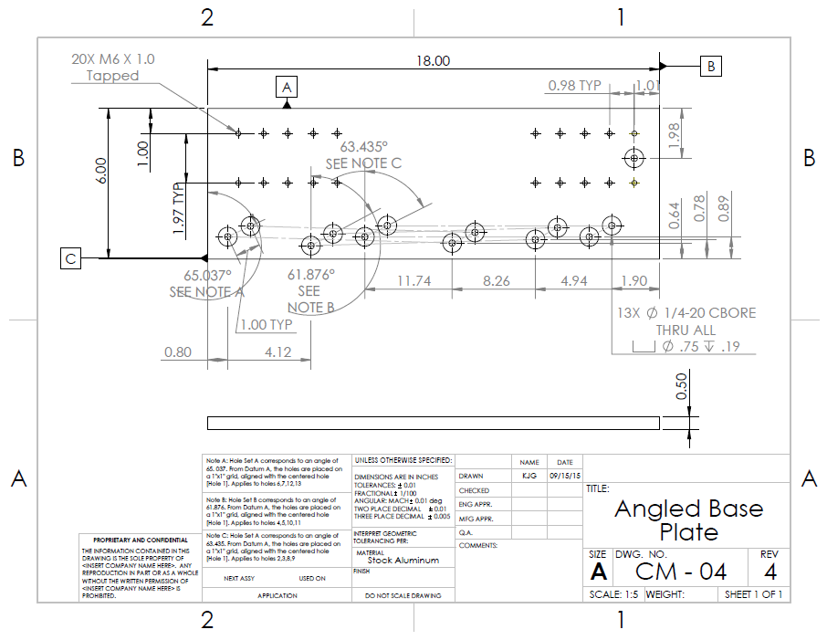

Figure 35 - Angled Base Plate

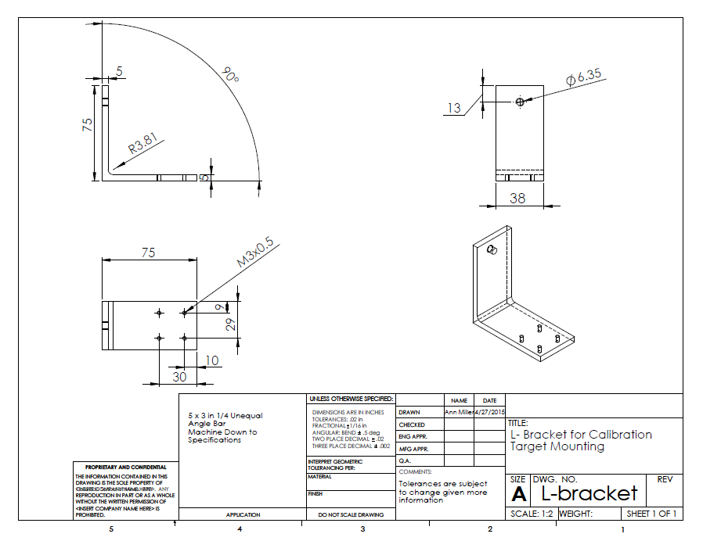

Figure 36 - Calibration Target L-Bracket

*Catalogue Cut Sheets*

Camera Theta Rotation Micrometer:

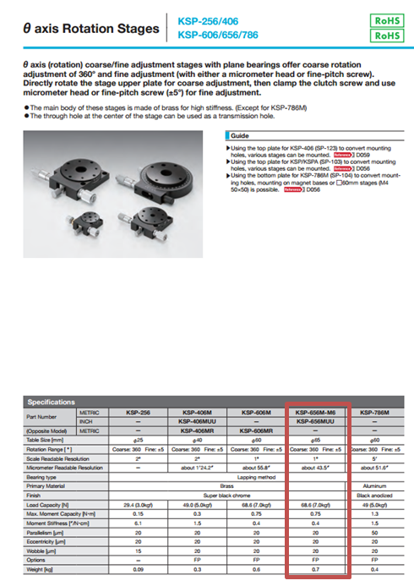

Linear Camera Track:

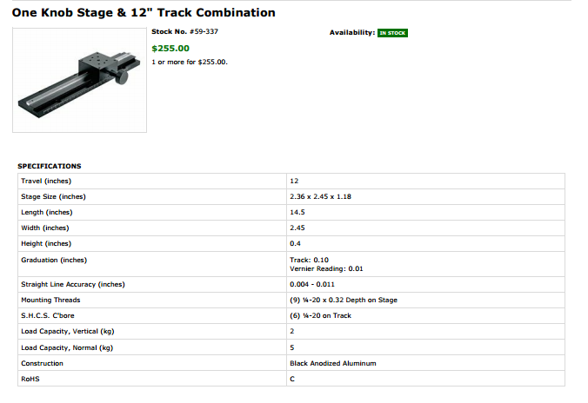

Linear Camera Track Carriage:

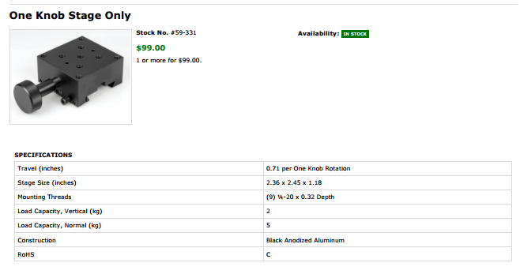

Camera Breadboard:

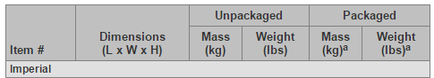

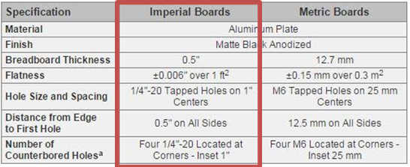

Small Breadboard for Mounting:

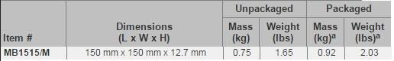

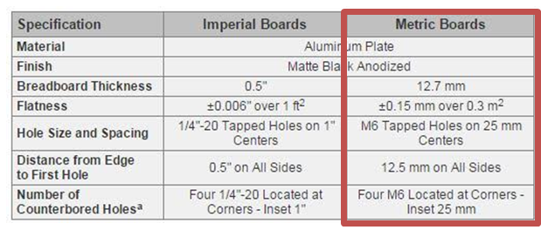

Linear Actuator

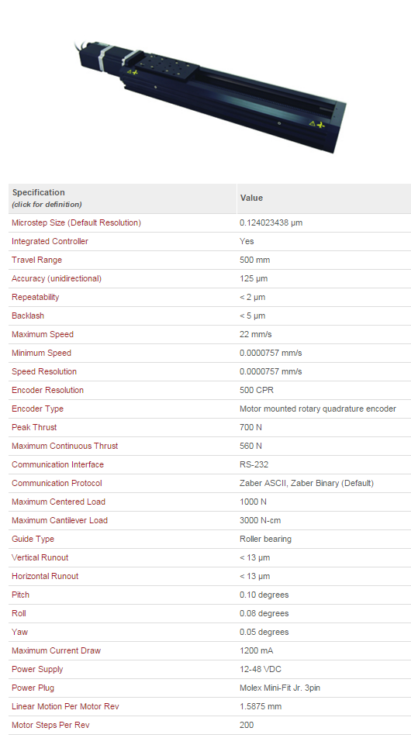

# Appendix I: Operators Manual

**Operators Manual**

Camera Mounting System



Figure 37 - Uniaxial Load Frame Configuration



Figure 38 - Dual-Axis (CSM) Load Frame Configuration



Figure 39 - Dual-Axis (Argonne Labs) Load Frame Configuration

*Calibration Target Assembly*

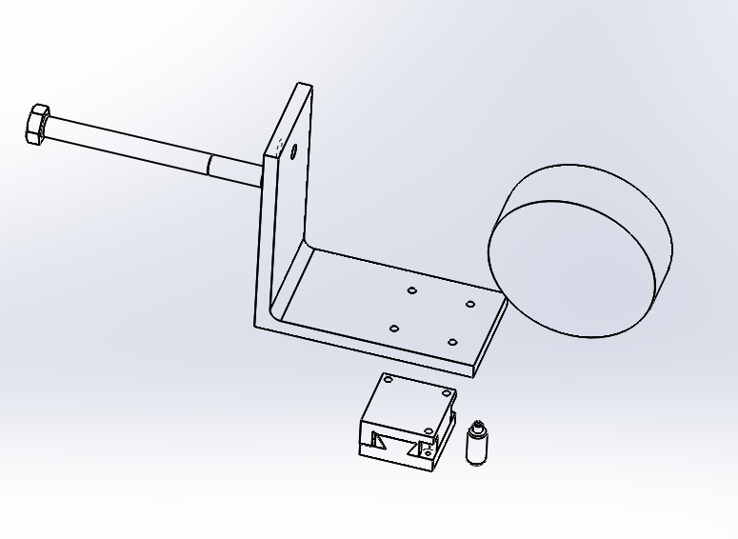

Figure 40 - Calibration target Assembly

* Please note that the linear slide is mounted with the three holes side attaching to the L-bracket with M3 Bolts

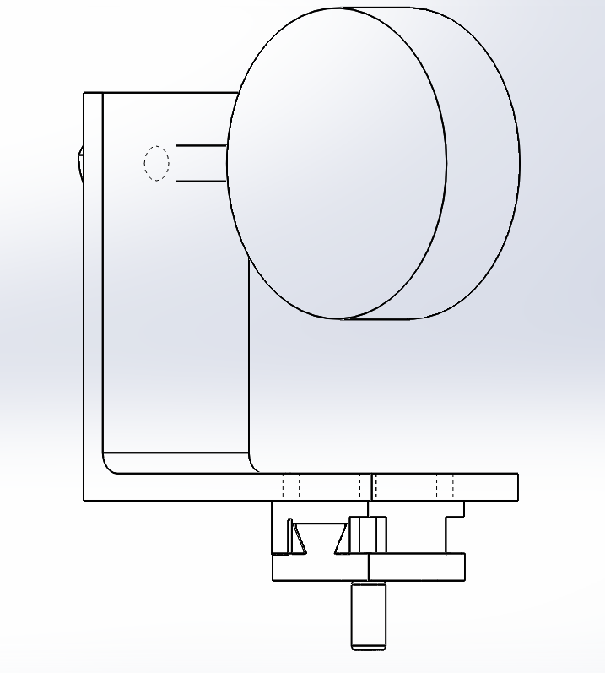

Figure 41 - Assembled Calibration Target

*Uni-Axial Load Frame Configuration*



Figure 37 - Uniaxial Load Frame Configuration

All components of this system are manually operated.

1. Assembly Instructions:
   1. Bolt the X, Y and Z linear stages together using ¼-20 bolts and screws, as needed.
   2. Bolt the Y stage (scissor lift) to the optical table at the desired location. Scissor lift should be centered.
   3. Bolt the small 18” x 6” breadboard to the top of the linear stages.
   4. Bolt the rack and carriage to the small 18” x 6” breadboard.
   5. Bolt the camera rotational stages to the rack and carriage linear stage.
   6. Mount cameras to the rotational stages using the corresponding L bracket orientation for that camera set.
      1. The L bracket will be screwed into the rotational stage first
      2. The camera screwed into the L bracket second, from the side.
   7. Mount laser to the small 18” x 6” breadboard, centered relative to the rack and carriage linear stage. The laser mount in the orientation corresponding to the camera set being used.
2. Operation Instructions:
   1. Align camera height and assembly horizontal placement based on the the laser pointing at the specimen.
      1. Use the Y stage scissor lift to set the cameras at a height even with the sample based on the laser.
      2. Use the two linear stages beneath the breadboard to line up the laser with the specimen center and to set the proper focal distance from the specimen.
   2. Use the rack and pinion to move the cameras to the correct distance apart.
   3. Use rotational stages to rotate cameras to aim at the specimen.
   4. Run calibration with the computer software and the calibration target.
   5. Run experiment with the specimen.

*Dual-Axis (CSM) Load Frame Configuration*



Figure 38 - Dual-Axis (CSM) Load Frame Configuration

All components of this system are manually operated.

1. Assembly Instructions:
   1. Bolt the X, Y and Z linear stages together using ¼-20 bolts and screws, as needed.
   2. Bolt the Y stage (scissor lift) to the optical table at the desired location. Scissor lift should be centered.
   3. Bolt the small 18” x 6” breadboard to the top of the linear stages.
   4. Bolt the rack and carriage to the small 18” x 6” breadboard.
   5. Bolt the camera rotational stages to the carriage on the rack and carriage linear stage.
   6. Mount cameras to the rotational stages using the corresponding L bracket orientation for that camera set.
      1. The L bracket will be screwed into the rotational stage first
      2. The camera screwed into the L bracket second, from the side.
   7. Mount laser to the small 18” x 6” breadboard, centered relative to the rack and carriage linear stage. Use the laser mount in the orientation corresponding to the camera set being used.
2. Operation Instructions:
   1. Align camera height and assembly horizontal placement based on the the laser pointing at the specimen.
      1. Use the Y stage scissor lift to set the cameras at a height even with the sample based on the laser.
      2. Use the two linear stages beneath the breadboard to line up the laser with the specimen center and to set the proper focal distance from the specimen.
   2. Use the rack and pinion to move the cameras to the correct distance apart.
   3. Use rotational stages to rotate cameras to aim at the specimen.
   4. Run calibration with the computer software and the calibration target.
   5. Run experiment with the specimen

*Dual-Axis (Argonne Labs) Load Frame Configuration*



Figure 39 - Dual-Axis (Argonne Labs) Load Frame Configuration

1. Assembly Instructions:
   1. Bolt the angled base plate to the optics table at the designated angle and distance from the load frame.
   2. See picture at bottom of document for placement of centering holes on optics table, and corresponding holes on the angle plate
      1. Align using the centering hole to x(5) for the 61.9° angle BLUE
      2. Align using the centering hole to x(6)for the 63.4° angle ORANGE
      3. Align using the centering hole to x(7) for the 65.0° angle GREEN
   3. Bolt the linear actuator to the angled base plate through the inside of the actuator.
   4. Extend linear actuator fully so that the c - channel is extended past the end of the actuator
   5. Bolt the Y-stage scissor lift to the cantilevered plate, from the bottom up using M6 bolts.
   6. Bolt the X and Z micrometer linear stages together using ¼-20 bolts and screws, as needed.
   7. Bolt the linear stages to the top of the Y-stage scissor lift.
   8. Bolt the small 18” x 6” breadboard to the top of the linear stages.
   9. Bolt the rack and pinion to the small 18” x 6” breadboard.
   10. Bolt the camera rotational stages to the carriage of the rack and carriage linear stage.
   11. Mount cameras to the rotational stages using the corresponding L bracket orientation for that camera set.
       1. The L bracket will be screwed into the rotational stage first
       2. The camera screwed into the L bracket second, from the side.
   12. Mount laser to the small 18” x 6” breadboard, centered relative to the rack and carriage linear stage. Use the laser mount in the orientation corresponding to the camera set being used.
2. Operation Instructions:
   1. Fully extend the linear actuator towards the load frame.
   2. Align camera height and assembly horizontal placement based on the the laser pointing at the specimen.
      1. Use the Y stage scissor lift to set the cameras at a height even with the sample based on the laser.
      2. Use the two linear stages beneath the breadboard to line up the laser with the specimen center and to set the proper focal distance from the specimen.
   3. Use the rack and pinion to move the cameras to the correct distance apart.
   4. Use rotational stages to rotate cameras to aim at the specimen.
   5. Run calibration with the computer software and the calibration target.
   6. Run experiment with the specimen.
      1. Before the load frame begins to rotate, retract the linear actuator fully so that the cameras are out of the way of the rotating load frame.
      2. When the load frame is stationary, extend the linear actuator to the same position as when they were calibrated.
      3. Repeat the extension and retraction as necessary
      4. Control the extension and retraction from outside the room for safe operation away from X-rays using the actuator controls.



Figure 29 - Angled Base Plate Placement Analysis

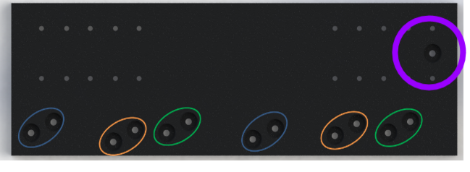

Figure 31 - Angled Base Plate Hole/Angle Options